Why Answering Service Customers Leave
and What Central AI Should Do About It

154 churn stories from 409 reviews | 9 competitors | Reddit & Trustpilot | 2015–2026

TL;DR
1. 79% of churn maps to two problems Central AI’s model solves. AI fixes call handling (45%). Flat-rate pricing fixes billing (33%). Both require a different business model, not just better technology.
2. Ruby and Smith.ai are bleeding customers. Ruby has the worst net flow (-4). Their customers are actively shopping.
3. The ratings are fake. Before mid-2024, organic reviews averaged 1.2–3.8 stars. Then sudden waves of 5-star reviews appeared. The real experience hasn’t changed.
4. AI-native proves the concept but can’t execute. Synthflow has 47% billing churn and 35% reliability churn. They solved calls. They broke everything else.
5. Lead with scripts and flat-rate pricing at $99–199/mo. That addresses 76% of churn and undercuts legacy pricing by 50–90%. Price isn’t why people leave — billing model is.

Contents
TL;DR 2
The Setup 2
How the Market Breaks 4
Who’s Bleeding 8
Why Now 11
The Play 14
Appendix: Methodology 18
Appendix: Evidence Samples 19
Appendix: Sample Raw Data 20
Appendix: All Churn Quotes 22

The Setup
Central AI is entering a market where thousands of small businesses — law firms, medical offices, home service companies — pay $235 to $2,800 per month for someone to answer their phones. These businesses can’t afford a full-time receptionist, so they outsource to an answering service. A remote agent reads from a script, takes a message, routes the call. The business pays per minute or per call.
The model has built-in problems. One receptionist juggles hundreds of clients. Training time per client is minimal. Staff turnover is high. Your “dedicated receptionist” is actually a stranger reading a script they saw 30 seconds ago.
I wanted to understand exactly how and why customers leave these services — not from the companies’ perspective, but from the customers’ own words. So I went to the two places where customers talk candidly: Reddit and Trustpilot.
I read 409 reviews of 9 answering services. 154 of them described a specific reason for leaving — not just “I’m unhappy” but a concrete complaint I could classify. I had two independent classifiers tag every single one into 11 categories. They agreed 142 out of 154 times (Cohen’s kappa = 0.91, “almost perfect” in stats terms). The 12 disagreements were all borderline cases within the same group.
What follows is the analytical journey through that data — the questions I asked, what I found, and what it means for you.

Where the data comes from
Every number in this document traces back to a real review. Here’s the breakdown by competitor:
Competitor | Trustpilot (churn) | Reddit (churn) | Churn Quotes | Trustpilot Link
AnswerConnect | 36 | 0 | 36 | https://www.trustpilot.com/review/answerconnect.com
Ruby Receptionist | 33 | 3 | 36 | https://www.trustpilot.com/review/ruby.com
PATLive | 28 | 0 | 28 | https://www.trustpilot.com/review/patlive.com
Smith.ai | 19 | 4 | 23 | https://www.trustpilot.com/review/smith.ai
Synthflow | 17 | 0 | 17 | https://www.trustpilot.com/review/synthflow.ai
Total: 154 churn quotes from 409 reviews. Every quote is linked to its original source in the appendix.

How the Market Breaks
The first question I asked was the most basic one: what exactly goes wrong? When a small business owner decides to leave their answering service, what pushed them over the edge?
Before I get into the numbers, it’s worth hearing the raw voice of the customer. I pulled one quote from each major failure group — not because they’re outliers, but because they’re representative of dozens of stories like them.
The Call Handling Problem
“They have wasted our ad budget, lost customers for us, and wasted hours of our time.”
— Smith.ai customer, Trustpilot
The Billing Problem
“They charged me $221 for overage charges for minutes I used that were included in my 200 minute plan.”
— AnswerConnect customer, Trustpilot
The Reliability Problem
“I have lost clients and potentially hundreds of thousands of dollars because of this company's negligence.”
— Smith.ai customer, Trustpilot
The Category Problem
“Not to mention I am now saving over $1,000 a month by cancelling my answering service!”
— Dialzara customer, Trustpilot

The four groups
Reading hundreds of these stories, a pattern emerged quickly. Every complaint falls into one of four groups — and the distribution isn’t even close to uniform. Call handling dominates.
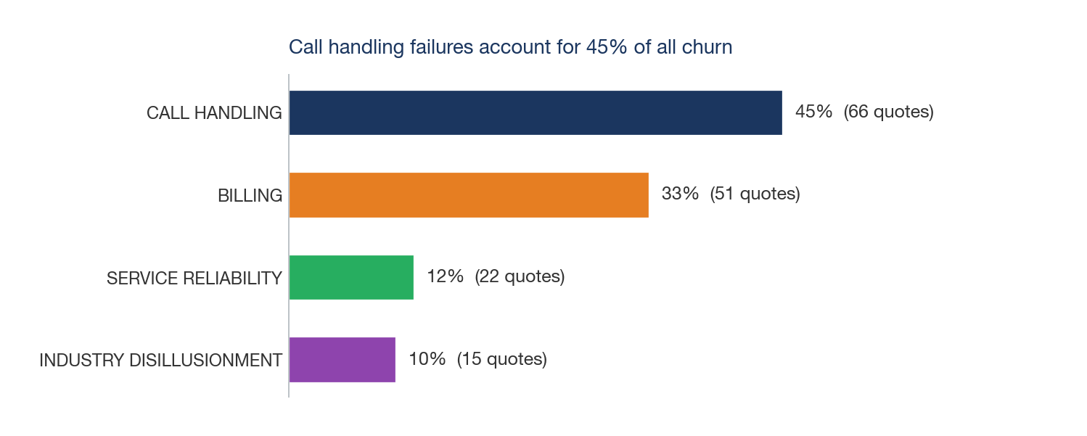
#1: CALL HANDLING — 45% of churn (66 quotes)
This is the core failure of the answering service model. Customers are paying for someone to represent their business on the phone, and that person doesn’t know the business, doesn’t follow the script, and garbles the information they collect. It’s not a training problem — it’s a structural one. A single receptionist juggling hundreds of clients will never match someone dedicated to one business.
Most of this is agents not following the script (19%, 32 quotes) and not knowing the business well enough to sound credible (16%, 15 quotes). A smaller chunk is basic data entry errors — wrong phone numbers, misspelled names, garbled emails (8%, 14 quotes). And a handful of cases where calls simply go to the wrong person (2%, 5 quotes).
Most affected: AnswerConnect (69%), Ruby Receptionist (44%), Smith.ai (39%)
#2: BILLING — 33% of churn (51 quotes)
The second-largest group is about how customers are billed, not how much. Per-minute billing creates perverse incentives: longer calls mean more revenue for the service, not better outcomes for the customer. Add in hidden charges for spam calls, after-call work time, and deliberately difficult cancellation processes, and you get a billing model that feels predatory — because it is.
The biggest slice is hidden charges and inflated bills (14%, 21 quotes) — customers charged for spam calls, billed for "after-call work" time, or upsold to plans they didn’t need. Then there’s the cancellation trap (9%, 15 quotes): services that make you email to cancel, require 30-day notice, or keep billing after you’ve stopped. Opaque pricing (6%, 11 quotes) rounds it out — bills that don’t match what was promised, charges no one can explain. Pure price sensitivity (4%, 4 quotes) is actually the smallest billing sub-problem.
Most affected: Synthflow (47%), Smith.ai (43%), Ruby Receptionist (33%)
#3: SERVICE RELIABILITY — 12% of churn (22 quotes)
These are the customers who were happy once. They signed up, it worked, and then something changed. Staff turnover, management shifts, growing pains — whatever the cause, the service degraded. The most painful quotes come from long-time customers who watched a good thing fall apart.
Most of this is quality decay (7%, 14 quotes) — 5-year customers who describe watching the service deteriorate, getting $10 credits for errors that cost them thousands. The rest is missed calls (4%, 8 quotes): messages delivered too late, callers put on hold until they hang up, leads lost to competitors before the business even knew they called.
Most affected: Synthflow (35%), PATLive (21%), Ruby Receptionist (17%)
#4: INDUSTRY DISILLUSIONMENT — 10% of churn (15 quotes)
Some customers have given up on the entire category. They’ve tried three, four, five answering services and concluded that none of them work. These are the highest-intent prospects for Central AI — they want the problem solved, they just don’t believe a human-pool model can do it.
All 15 quotes in this group describe the same pattern: a business owner who has tried multiple answering services and is looking for something fundamentally different. They’re not comparing feature lists — they’re asking whether the entire category can work.
Most affected: PATLive (14%), Smith.ai (9%), Synthflow (6%)

Where churn concentrates
The next question I asked was about concentration: are complaints spread evenly across all 11 categories, or do a few dominate? This matters for you because it determines whether Central AI needs to solve everything or can win by solving a few things well.
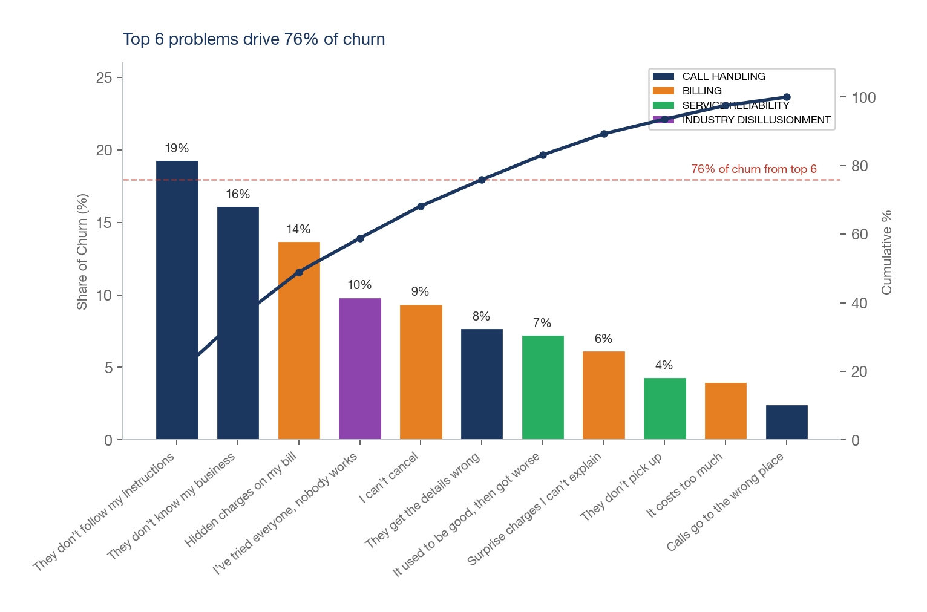
The data is decisive. The top 6 reasons account for the vast majority of churn. Everything below the line is real, but it’s diminishing returns. This means Central AI doesn’t need to be perfect at everything — it needs to be excellent at scripts, inauthenticity, and billing.

What happens when you switch to AI?
Here’s where I asked a question that turned out to be more interesting than expected: if the core problem is human receptionists failing at calls, does switching to AI fix it?
Synthflow is the only AI-native competitor with enough data to analyze (17 churn quotes on Trustpilot). And the answer is nuanced. AI does solve the call handling problem — script adherence complaints essentially vanish. But churn doesn’t vanish. It moves.
- Call handling drops from 44–69% (legacy) to 12% (Synthflow). AI follows the script every time. That specific problem is solved by design.
- But billing jumps to 47% and reliability to 35%. Synthflow customers complain about bait-and-switch pricing, features locked behind enterprise plans, and a platform that breaks silently.

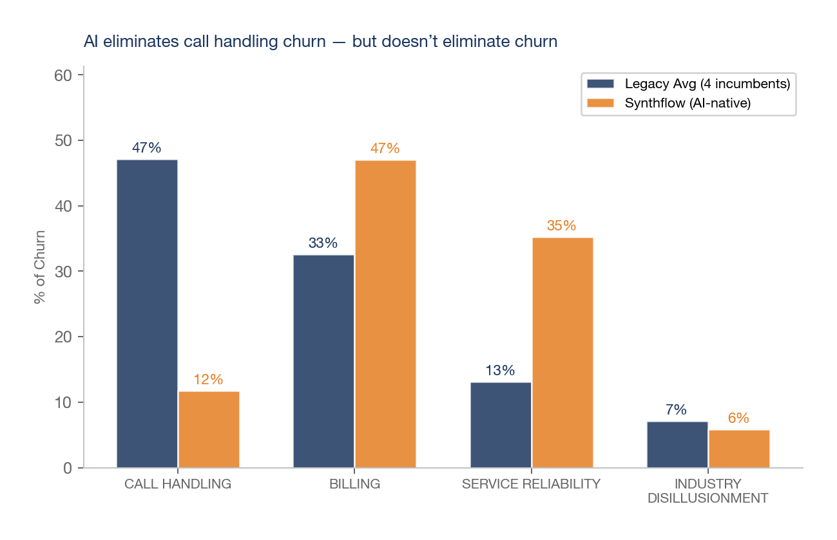
This is a crucial insight for Central AI. Winning isn’t just about having an AI that handles calls well — Synthflow already proved that’s possible. Winning means avoiding both failure modes: the call handling problems that plague legacy services AND the billing and reliability problems that plague the AI-native ones. The bar isn’t “better than human receptionists.” The bar is “better than human receptionists, without introducing new reasons to leave.”

Who’s Bleeding
At this point I knew what breaks. The next question was more actionable: does every competitor fail the same way, or are some more vulnerable than others? If you’re going to target churning customers, you need to know whose customers to target and what message will resonate with them.

Each competitor fails differently
I cross-tabulated every churn quote by competitor and failure group. The heatmap below shows what percentage of each competitor’s churn falls into each group. The differences are striking — these companies don’t just fail, they fail in distinctive ways.
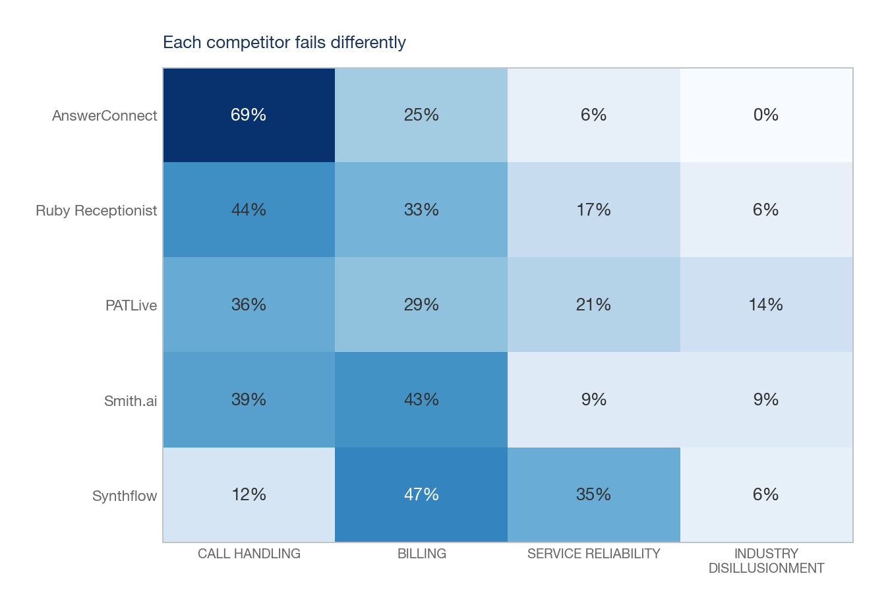
- AnswerConnect (36 churners): 69% call handling. Top complaints: They don’t follow my instructions (12), Hidden charges on my bill (7).
- Ruby Receptionist (36 churners): 44% call handling. Top complaints: They don’t follow my instructions (8), It used to be good, then got worse (5).
- PATLive (28 churners): 36% call handling. Top complaints: They don’t follow my instructions (4), I’ve tried everyone, nobody works (4).
- Smith.ai (23 churners): 43% billing. Top complaints: They don’t follow my instructions (7), I can’t cancel (4).
- Synthflow (17 churners): 47% billing. Top complaints: It used to be good, then got worse (4), Hidden charges on my bill (4).
This tells you something important: the go-to-market message for a Ruby churner (“your calls will be handled right”) is completely different from the message for a Smith.ai churner (“transparent billing, cancel anytime”). One size won’t fit all.

Where customers go when they leave
I then looked for switching stories — reviews where a customer named both the service they left and the one they moved to. I found 30 of them. That’s a small sample, so treat the direction as signal, not the exact numbers as proof. But the pattern is consistent.
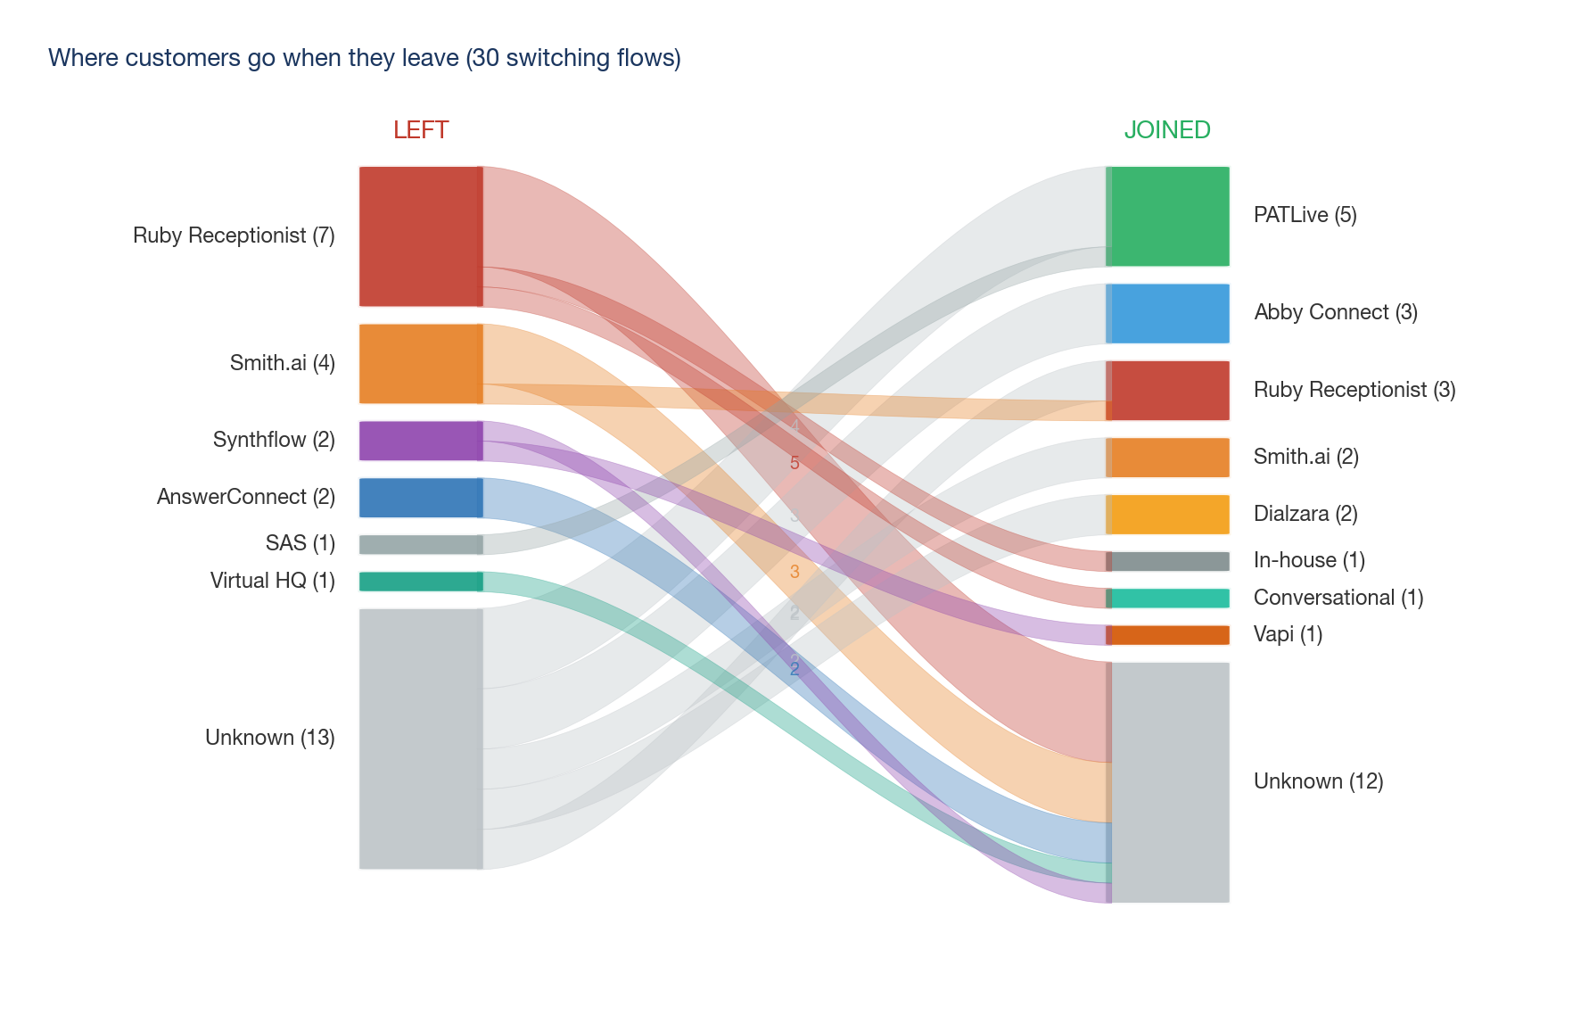
The chart maps each of the 30 switching stories as a flow from the company a customer left (on the left) to the one they joined (on the right). The “Unknown” band is large — most reviewers name only one company, not both — but among those who do name names, the pattern is clear.
On the departures side: Ruby Receptionist (7), Smith.ai (4), AnswerConnect (2). Ruby stands out as the biggest named source of churning customers.
On the arrivals side: PATLive (5), Ruby Receptionist (3), Abby Connect (3). PATLive appears to be catching the most named switchers, which aligns with their reputation for customization and onboarding support.
The trigger breakdown reinforces what the churn data already showed: quality (20/30), capability (4/30), pricing (6/30). People switch because the calls are handled badly — not because of price, not because of missing features. This is the opening for Central AI.
Confidence note: 30 switching stories is directional signal, not statistical proof. The pattern is consistent (quality-driven, Ruby losing) but the sample is small.

The dollar amounts are real
One question I anticipated you’d ask: are these real businesses spending real money, or just price-sensitive bargain hunters who’d churn from anything?
The data answers clearly. 22 of 154 churn quotes mention specific dollar amounts — these are businesses spending hundreds to thousands per month. And the complaints aren’t about the price being too high (“It costs too much” is only 4% of churn). They’re about how they’re billed: surprise charges, per-minute inflation, impossible cancellation. These customers aren’t looking for cheaper — they’re looking for fairer.
- Hidden charges on my bill (21 quotes, 14% of churn)
- I can’t cancel (15 quotes, 9% of churn)
- Surprise charges I can’t explain (11 quotes, 6% of churn)
- It costs too much (4 quotes, 4% of churn)

Why Now
So far I’ve shown you what breaks and who’s most vulnerable. But there’s an obvious question you should be asking: if these services are so bad, why haven’t customers already switched to something better? Is this actually a moment of opportunity, or has the market already settled?
I dug into the timing data to find out. What I found surprised me.

The ratings are fake
If you look at Trustpilot today, these companies look fine. Some even look good. I almost stopped here — maybe the churn quotes were just the vocal minority. Then I split the reviews by date and saw something that changed the picture entirely.
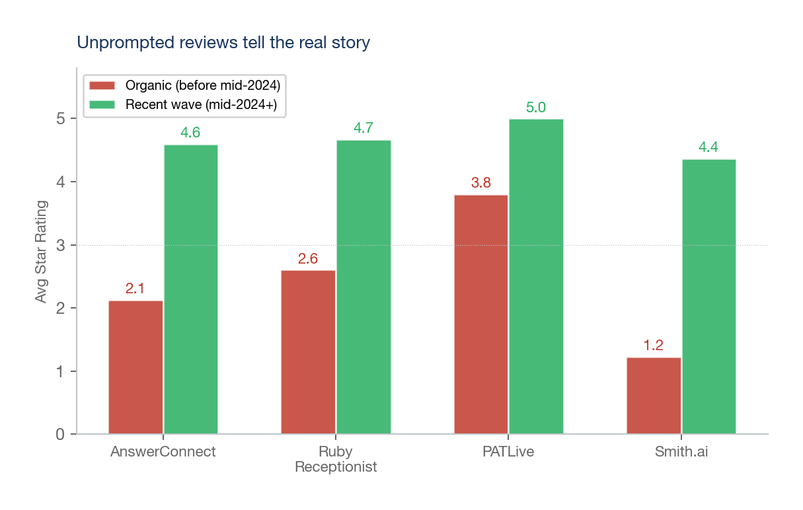
Before mid-2024, when reviews were purely organic, the average ratings for these companies ranged from 1.2 to 3.8 stars. Then, starting around mid-2024, waves of 5-star reviews appeared across multiple companies simultaneously.
- AnswerConnect: organic avg 2.1 (38 reviews) → recent 4.6 (67 reviews)
- Ruby Receptionist: organic avg 2.6 (56 reviews) → recent 4.7 (46 reviews)
- PATLive: organic avg 3.8 (72 reviews) → recent 5.0 (16 reviews)
- Smith.ai: organic avg 1.2 (13 reviews) → recent 4.4 (60 reviews)

Smith.ai had zero 5-star reviews before mid-2024. Then 49 appeared. AnswerConnect: same — zero, then 59. The service didn’t change. The review strategy did.

The distribution proves it
I wanted to be rigorous about this claim, so I looked at the star distribution. If these services were genuinely improving, you’d expect reviews to spread across 1–5 stars — some lingering dissatisfaction, some moderate improvement, some genuine fans. That’s not what the data shows.
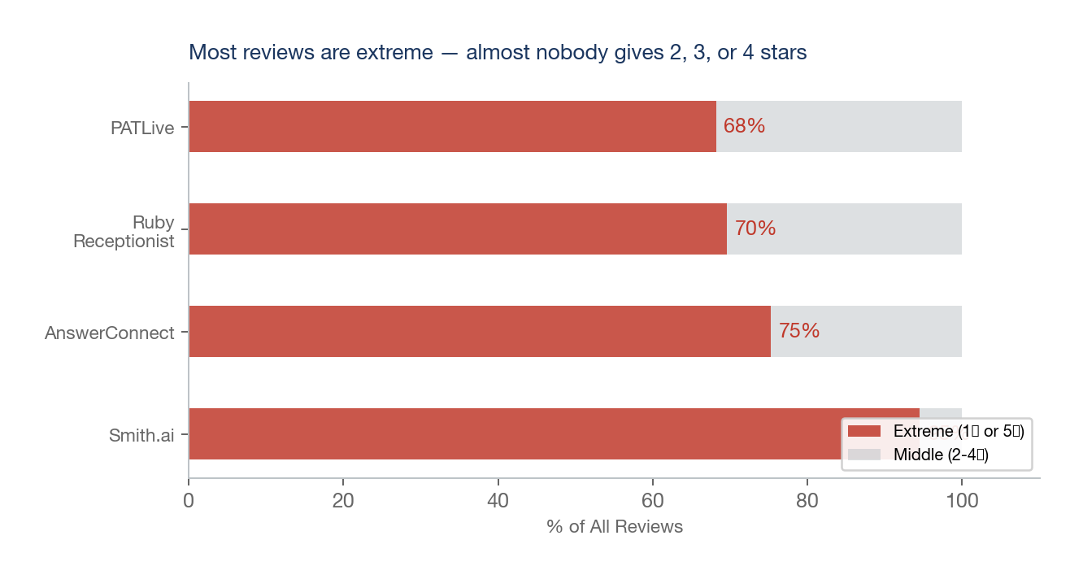
Instead, reviews cluster at the extremes — almost nobody gives 2, 3, or 4 stars. This is a classic fingerprint of two separate populations: unhappy organic reviewers and solicited positive reviewers. The barbell distribution tells you the positive reviews are from a different population than the negative ones.
- Smith.ai: 95% extreme. Unprompted 5-star: 0/13. Recent 5-star: 49/60.
- AnswerConnect: 75% extreme. Unprompted 5-star: 0/38. Recent 5-star: 59/67.
- Ruby Receptionist: 70% extreme. Unprompted 5-star: 10/56. Recent 5-star: 41/46.
- PATLive: 68% extreme. Unprompted 5-star: 38/72. Recent 5-star: 16/16.

Here’s what this means for you: the real competitive landscape is much weaker than Trustpilot suggests. You’re not competing against 4-star services. You’re competing against the organic experience (1.2–3.8 stars). The bar is low.

AI-native competitors are proving the concept
I also looked at the AI-native alternatives that have entered the market. Dialzara (14 reviews, 5.0 avg) and My AI Front Desk (8 reviews, 5.0 avg) show the AI receptionist concept resonates with customers — but these are tiny samples, too small to draw conclusions from.
Synthflow, with 69 reviews, shows what happens at scale: billing and reliability become the new battleground. The AI handles calls fine. The company behind it doesn’t.
But here’s the urgency: Bland AI raised $65M (YC, Emergence Capital). Synthflow has backing from Atlantic Labs. These are well-funded teams who will eventually fix their execution problems. The window where AI-native competitors have broken platforms is temporary. You need to move while it’s open.

What competitors can and can’t fix
Before jumping to recommendations, I asked one more question: which of these competitive weaknesses are permanent, and which are temporary? If a competitor can patch their way out of a problem, you shouldn’t build your strategy around it. You should bet on the structural ones — the problems baked into their business model.
Problem | Structural or Patchable? | Why
Agents don’t know the business | Structural | Shared-pool model: one receptionist juggles hundreds of clients. Adding an AI screening layer doesn’t fix the human’s lack of context.
Per-minute billing incentives | Structural | Revenue = call duration. Flat-rate would cannibalize the business model. This is the innovator’s dilemma — incumbents can’t switch without destroying margin.
Staff turnover → quality decay | Structural | Human call centers have 30–45% annual turnover. Constant retraining is the norm, not a fixable bug. New hires will always be worse than tenured staff.
Script adherence | Patchable (slowly) | Better training helps marginally, but is limited by the shared-pool constraint. An agent handling 200 clients will never master all 200 scripts. AI solves this by design.
Technology integrations | Patchable | CRM integrations, scheduling APIs — these can be added. Smith.ai is already moving here with their hybrid model.
Review solicitation | Patchable | Already happening (the mid-2024 surge). Masks the problem but doesn’t fix it.

Bottom line: the three biggest pain drivers (scripts, inauthenticity, billing model) are structural. Competitors would have to rebuild their entire business to fix them. That’s the moat you should build around.

The Play
So here’s what the data tells you. Legacy services can’t fix their structural problems. AI-native entrants have the right idea but haven’t earned customer trust yet. The real ratings show incumbents are far weaker than their Trustpilot pages suggest. And the window is open but closing as well-funded competitors fix their platforms.
The rest of this section translates those findings into specific product, pricing, and go-to-market recommendations. Everything ties back to a number from the data above.

What to build
I plotted every churn category on two axes: how much churn it drives (impact) and how naturally AI solves it (ease). The upper-right quadrant — high impact, high AI advantage — is where you should focus first.
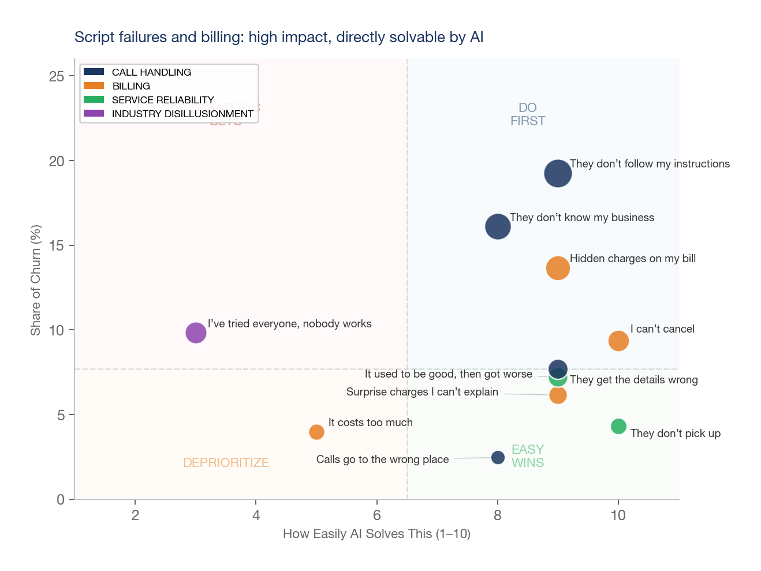
Three features land squarely in that quadrant. Here’s what they look like as product requirements:
Priority | Product Feature | Churn It Prevents | What Customers Said
P0 | Configurable call scripts with branching logic | “They don’t follow my instructions” (19%) | AI IS the script, not reading one
P0 | AI trained per client: business FAQ, repeat caller recognition | “They don’t know my business” (16%) | Dedicated AI vs stranger with a screen
P0 | Flat monthly rate, no per-minute billing | “Hidden charges on my bill” (14%) | Eliminate the per-minute incentive entirely
P1 | Structured data capture with spell-back validation, CRM push | “They get the details wrong” (8%) | Structured forms, not free-text note-taking
P1 | Self-serve cancellation, no contracts, no 30-day notice | “I can’t cancel” (9%) | One-click cancel, no hoops
P1 | Real-time usage dashboard with itemized call logs | “Surprise charges I can’t explain” (6%) | Show every call, every charge, in real time
P2 | 24/7 instant answer, zero hold time | “They don’t pick up” (4%) | AI doesn’t have staffing gaps
P2 | Automated quality monitoring, no staff turnover | “It used to be good, then got worse” (7%) | “Used to be great, now it’s terrible” — Day 1000 = Day 1

P0 features address 49% of all churn. Ship these before anything else.

What to charge
I looked at what the churn data says about pricing. The signal is unambiguous: the problem isn’t how much these services charge — it’s how they charge.
- “It costs too much” is only 4% of churn. Price is not why people leave.
- All billing complaints combined is 33% of churn. How they’re billed is why people leave.
- Dollar amounts in complaints: 22 of 154 churners mention specific dollar amounts ($3–$3,000). They’re spending real money and expecting real service.

Segment | Current Pricing | Central AI Opportunity
Legacy incumbents | $235–$2,800/mo (per-minute) | Undercut by 50–70% while eliminating per-minute surprises
AI-native (Synthflow etc.) | $29–$450/mo (per-minute + base) | Price similarly but deliver reliability and support they can’t
Recommended range | — | $99–199/mo flat rate. Above AI-native noise, below legacy pain. Flat-rate directly addresses billing-model churn (29% of all churn: predatory billing, billing traps, and opaque charges).

Flat-rate pricing isn’t just a feature — it’s a structural advantage you should lean into. Incumbents can’t match it without destroying their per-minute revenue model. That’s the innovator’s dilemma working in your favor.

How big is this
You’ll want to know the size of the opportunity. I built a bottoms-up estimate using what this analysis gives us. It’s intentionally conservative — I’d rather give you a number you can defend than one that sounds impressive.
Input | Estimate | Source
Ruby customer base | 15,000+ | Ruby’s public marketing
Four legacy incumbents combined | ~40,000–60,000 SMBs | Estimate from Ruby (15K) + AnswerConnect, PATLive, Smith.ai
Annual churn rate (industry) | 15–25% | Typical for B2B SaaS/services; our data shows persistent dissatisfaction
Customers actively shopping/year | ~6,000–15,000 | 40–60K base × 15–25% churn
Central AI capture rate (year 1) | 1–3% | Conservative for a new entrant with no brand
Capturable accounts (year 1) | 60–450 accounts | Rows above
At $149/mo average | $107K–$804K ARR | Accounts × $149/mo × 12

This is conservative. It excludes AI-native switchers, new market entrants, and the long tail of smaller answering services not in this dataset. The real TAM is larger — but even the conservative case shows a viable beachhead.

Who to target
Based on the competitor vulnerability data and switching patterns, here’s who I’d prioritize and in what order. The logic: start with the highest-intent, most-accessible customers and work outward.
Priority | Target | Why (from data) | Lead Message
1 | Ruby churners | Worst net flow (-4), quality decay complaints, 44% call handling churn | “Your calls handled right, every time”
2 | Smith.ai churners | Billing-driven churn (43%), net -2, customers describe “intentionally difficult” cancellation | “Transparent pricing, cancel anytime”
3 | Serial switchers | 15 quotes describing trying 3–4 services. Highest-intent prospects — they’ve given up on the category | “Different technology, not another answering service”
4 | Synthflow refugees | 47% billing churn, 35% reliability. They wanted AI but got a broken platform | “AI that actually works, with real support”

What to say
Each channel should lead with the pain point most relevant to the audience it reaches. I mapped the churn categories to specific channels and drafted messages grounded in the exact language customers use in their complaints.
Channel | Message | Pain It Addresses | % of Churn
Google Ads / SEO | “AI receptionist that follows your script” | “They don’t follow my instructions” | 19%
Trustpilot competitor pages | “Flat rate. No per-minute billing. Cancel anytime.” | All billing complaints | 33%
Competitor review responses | “Same problem? We built something different.” | “I’ve tried everyone, nobody works” | 10%
Direct outreach — Ruby customers | “Still happy with your call quality?” | “It used to be good, then got worse” | 7%
Direct outreach — Smith.ai customers | “Tired of surprise charges? We do flat rate.” | “Hidden charges” + “Surprise charges” | 20%

What could go wrong
I wouldn’t give you a recommendation without flagging the risks. The Synthflow data is instructive here: it shows that AI doesn’t eliminate churn — it shifts it. Here are the failure modes you need to plan for, along with what I’d suggest doing about each.
Risk | Evidence from Data | Mitigation
Billing becomes the new churn driver | Synthflow: 47% of churn is billing (bait-and-switch, hidden costs). AI-native doesn’t mean billing-clean. | Flat rate from day one. No usage tiers that surprise. Publish pricing publicly. Self-serve cancellation.
Platform reliability failures | Synthflow: 35% reliability churn. Silent breaking updates, features stop working, support absent. | Invest in engineering discipline early. Uptime SLA. Status page. Regression test suite before every deploy.
Callers detect ‘outsourced’ feel | “They don’t know my business” is 16% of legacy churn — callers notice when the receptionist doesn’t know the business. AI could trigger the same reaction for a different reason (robotic tone vs clueless human). No AI-specific data yet — AI-native services are too new. | AI must be trained per client. Graceful handoff to human when AI is uncertain. Don’t pretend to be human — be upfront and be competent.
New competitors fix their problems | Bland AI ($65M raised), Synthflow (Atlantic Labs). Well-funded teams will eventually fix billing and reliability. | Speed matters. The window is open now. First mover with reliable AI + clean billing wins. Build switching costs through CRM integrations and client-specific AI training.

Appendix: Methodology
Data: 409 reviews scraped from Trustpilot (9 companies) and Reddit (7 subreddits). Filtered to 154 with a specific churn reason.
Classification: 11-category taxonomy with clear decision rules. Two independent AI classifiers tagged every quote. Agreement: 142/154 (92.2%). Cohen’s kappa: 0.91 (“almost perfect”). 12 disagreements manually reviewed.
Weighting: Detailed, highly-upvoted Reddit posts carry more weight than one-line reviews. Weight = quote_quality × log₂(upvotes) for Reddit, quote_quality × 1.0 for Trustpilot.
Known limitations:
- 92% Trustpilot, 8% Reddit. Trustpilot skews negative.
- All Reddit churn quotes from r/LawFirm.
- Both classifiers are AI — may share blind spots.
- 34 of 154 quotes are pre-2020. Complaint types hold across time windows; competitor ranking shifts slightly.
- Mid-2024 review surge cutoff is judgment-based.

Temporal sensitivity: Complaint types (call handling ~45%, billing ~33%) hold in both all-dates and post-2020 windows. Competitor ranking shifts: Ruby and Smith.ai move up in recent data, AnswerConnect moves down.

Appendix: Evidence Samples
Three representative quotes per failure group, ranked by quality score.
CALL HANDLING (66 quotes)
- “I came to the conclusion that if I was going to hire a remote paralegal for X amount of $ already, I’d rather spend a to...” — Virtual HQ (Reddit)
- “Costs about $700/month depending on volume.” — Ruby Receptionist (Reddit)
- “The first few client complaints I ignored because I thought “clients can be tough” but after the 4th complaint I realize...” — Smith.ai (Reddit)

BILLING (51 quotes)
- “Used smith.ai for about two years.” — Smith.ai (Reddit)
- “I tried out Call Ruby (a US-based virtual receptionist service).” — Ruby Receptionist (Reddit)
- “When Upgrading service I was charged over 10 minutes (yeah $30) for their internal testing.” — Ruby Receptionist (Trustpilot)

SERVICE RELIABILITY (22 quotes)
- “Smith.ai used to be fantastic, they have been our answering service of choice for over 8 years.” — Smith.ai (Trustpilot)
- “Just got an email of a message to call a customer from 05/23/16.” — AnswerConnect (Trustpilot)
- “I have lost clients and potentially hundreds of thousands of dollars because of this company's negligence.” — Smith.ai (Trustpilot)

INDUSTRY DISILLUSIONMENT (15 quotes)
- “I’ve used a few services and am not happy with them.” — Other (Reddit)
- “first, that is the third split as mentioned above is probably better.” — Smith.ai (Reddit)
- “Dialzara is by far the best and most user-friendly option we’ve come across.” — Dialzara (Trustpilot)

Appendix: Sample Raw Data
Every claim in this document traces to a real review. Here are 10 sampled quotes with their original source links.
# | Competitor | Category | Quote (truncated) | Source
1 | Virtual HQ | They don’t know my business | “Background: General practice solo (rep a ton of businesses, ep, probate, have so...” | Reddit: https://reddit.com/r/LawFirm/comments/1q7jhqv/_/nyi4b5i
2 | Ruby Receptionist | They don’t know my business | “We use Ruby. Not sure if they handle Spanish. We get about 500 inbound calls p...” | Reddit: https://reddit.com/r/LawFirm/comments/190sf6s/_/kgqbd9y
3 | Smith.ai | They don’t know my business | “We dropped Smith.ai for the same reason. The first few client complaints I ignor...” | Reddit: https://reddit.com/r/LawFirm/comments/1bl4qtc/_/kw2ryfw
4 | Smith.ai | It costs too much | “Used smith.ai for about two years. They were great, but became more expensive. P...” | Reddit: https://reddit.com/r/LawFirm/comments/1bvnhk0/_/ky0fppf
5 | Ruby Receptionist | It costs too much | “I tried out Call Ruby (a US-based virtual receptionist service). They were real...” | Reddit: https://reddit.com/r/LawFirm/comments/1cbj683/_/l115m0s
6 | Ruby Receptionist | Hidden charges on my bill | “It is a great service with numerous hiccups. The number that RUBY assigned me t...” | Trustpilot: https://www.trustpilot.com/reviews/5c2f8b839d37800b040d1016
7 | Smith.ai | It used to be good, then got worse | “Smith.ai used to be fantastic, they have been our answering service of choice fo...” | Trustpilot: https://www.trustpilot.com/reviews/6904b43df0cadc93d679d972
8 | AnswerConnect | They don’t pick up | “Just got an email of a message to call a customer from 05/23/16. We called him ...” | Trustpilot: https://www.trustpilot.com/reviews/57587f480000ff0009640080
9 | Smith.ai | It used to be good, then got worse | “This is now the fourth time the company fail to make a call after telling me tha...” | Trustpilot: https://www.trustpilot.com/reviews/666dbce1d7f63c429e050507
10 | Other | I’ve tried everyone, nobody works | “Best virtual receptionist/google ads Hey just wondering if 1) anyone can make a...” | Reddit: https://reddit.com/r/LawFirm/comments/183yb9d/best_virtual_receptionistgoogle_ads/
Full database of all 154 quotes with source links available in the supplementary data files.

Appendix: All Churn Quotes
All 154 churn quotes organized by customer-voiced failure mode. Quotes are ranked by quality score within each category.

CALL HANDLING (66 quotes, 45% of churn)
“They don’t follow my instructions” (32 quotes, 19%)
Source | Quote
Conversational  reddit  2026-01-09 | “I've used conversational answering service for years. It's much better than when I started with nobody but they do have a ceiling. This service does not follow a script. They will do bookings for you but combined with them not following a script it makes quality control on the bookings difficult as they are operating without solid guardrails of what your criteria are. If you can afford it, get a full time remote receptionist that will know more about your business than any agency ever will.”
PATLive  trustpilot  2025-03-06 | “I just wanted to share my experience with PATLive after finding them in the App Marketplace for Jobber. I gave them a call and chatted with Jessica Pacheco about what I needed. We dove into some challenges I was facing with my old call center, and let me tell you, Jessica was super helpful! She hooked me up with an onboarding session with Amy Hearn for a 14-day free trial. Amy laid out the onboarding process for me and promised she’d be there until everything was running smoothly. I had been with another call center for years, but Amy and Jessica had a totally different vibe when it came to meeting my business needs. My previous rep was nice, but it always felt like I was hitting a wall with, "We can't do that for your company." I was expected to just go along with their way of doing things. But with Amy and Jessica, they made it clear they had solutions for my past issues and were totally open to CUSTOMIZING how my calls were handled. Now, PATLive answers 100% of my calls, and based on my custom setup, they can schedule, forward, mark as spam, or enter leads into my system. Plus, they’ve got this handy app that lets me monitor calls and sends me text and email alerts. If I ever have questions or concerns, Amy or any of my PATLive agents are always ready to help out! Honestly, there was no need for a 14-day trial to convince me—PATLive won me over from Day One!”
AnswerConnect  trustpilot  2024-02-06 | “It didn't work as we envisioned. There were parts I loved and things that I wish worked better: Good - The best experience with AnswerConnect was definitely Candy Oakes and her assistance to help resolve problems. She is constantly keeping in touch to make sure needed changes happen and that problems are addressed right away. If there was a way to have her answering our calls, we would probably be completely satisfied. I loved that calls were always answered quickly so that our clients never had to play phone tag or go press multiple options to get to someone. Bad - some receptionists I really wish weren't answering our calls. They did not listen to what the caller is saying, and often scheduled the incorrect time zone repeatedly. I had to repeatedly call callers back to correct the scheduled time or other type problem. Often times I was spending way more time calling back clients than if I had answered the phone myself. We would have kept using AnswerConnect services and worked with Candy but because the receptionists can really only work off of a script and don't have access to the caller's information, it made it difficult to get the caller to the correct person. I can see it working well for other type businesses, but can now see that it isn't a good fit for us.”
AnswerConnect  trustpilot  2015-11-12 | “There was a system issue that erased our script and messages where taken as if they were calling an answering machine. We are a small law firm and each call is someone calling for help. Our script is such you would think they were in our office and they actually book consults for us. We finally caught it and was restored. There should have been a better redundancy and quality check before they upgrade anything. While I have delayed in some of my responses to customer service, initially I was all over it and asked for escalation to a manager, it would be days before I would here from them. I do not even think a manager ever emailed us. And it was different people that would respond. Something this mission critical should have escalated past a manager and to an Executive who should have followed up with us. I will say prior to that we had been very happy with AnswerConnect. The true test of any company is the urgency at which they respond when there is a problem. There was none. The old saying applies, "the problem is not the problem, how we deal with the problem is the problem"  Disappointingly,  Mike”
Smith.ai  trustpilot  2021-01-12 | “This is a TRUE feedback from a VERY disappointed & furious customer. We were looking for a 24/7 answering services for our English customers who can be anywhere in the world. We signed with this pathetic company 10 days ago Actually writing this comment, we don't have any working phone number or chat they decided WITHOUT ANY NOTICE to cut their “service “(we are in the middle of the week end) so our potential leads cannot join us and we have to take all our weekend to find a replacement solution with anybody off. We took time to write a complete written process to be followed by their agents, the first 3 days we had to explain them what to do, what to not do ( even the process is easy like a 10 years old boy can understand) but they didn't follow it even after several emails & checks by calling & chatting with them they didn’t. An example of a recurrent idiot problem ? their low IQ agents cannot take INTERNATIONAL phone number standard like +XX (country) (cause our customers can be from anywhere) we sent them several emails , 7 ones on this particular point, no changes , I had to speak with 2 of their managers for nothing, guess what , no changes they still took the phone numbers like everyone is from USA (without country code) and this is a example they didn’t follow our other processes either. Yesterday, been so furious of their incompetence to not follow a single process like this I sent them "do your job this is pathetic" or we will leave And then we received a 'w”
AnswerConnect  trustpilot  2025-01-28 | “Hi, I have a law firm with 228 five star reviews. We use Answer Connect. Recently I received a one-star review from a potential client who stated that the receptionist was rude and unprofessional. This is our first one star review ever. I went back and listened to the recording of the call. It was true that the receptionist was rude and unprofessional. Furthermore, I believe this potential client was targeted by the receptionist because of the potential callers race. The call before it by the same receptionist the same day was totally fine, but then she was rude to this different-race caller. When I brought the behavior to the attention of Answer Connect, they sympathized but they said the receptionist, Mia B. would remain in my rotation.”
AnswerConnect  trustpilot  2023-01-04 | “It is getting frustrating They attention is good, but untimely. Changes I request take too many steps to get done. Every time I want to update the script, I have to send a chat, then someone contacts me (normally after hours), then back and forth of emails, because they never call when I ask or they don't care to send a meeting invite to have it properly scheduled. Then I have to validate the script, and then send an email back. This script form/program you use is not customer friendly and when changes are needed urgently that is just not a possibility. Your agents do follow script but I've heard calls where that is all they do, there is not attempt to make sense of the information provided and common sense is lacking most of the time. The call volume we get is not high by any means, and I wonder how much more complaints I would get if we had more customers calling in. We have decided to move away from answer connect during 2023 and take the hit on expensing the resources ourselves just because we can't trust there will be consistency on how calls are attended.”
AnswerConnect  trustpilot  2022-02-25 | “We are a professional financial investments firm who was just looking for someone to answer 10-20 calls per day. AnswerConnect was very happy to work with us and took $374.99 for the first month (200 mins). After sending the funds, we then worked with a scripter to try and get our calls into their system. Unfortunately, things started to go wrong as the gentleman was unable to grasp our business and we lost 2 weeks with completely ineffective scripts that had to be reworked. Once we finally drafted the script in full ourselves the script was as good as it could be, but then we ran into multiple call handling issues by the agents themselves who were completely unprofessional sounding, didn't always follow the script and ultimately didn't know what to do with our calls. After flagging these calls to AnswerConnect we repeatedly just got told "I've reviewed the call recording and found that the call does not meet our quality assurance expectations. Since this call does not meet our expectations, I have asked the agent to be coached on this”. We finally reached out to our Contact who just replied: “I do realize you have been running into multiple call handling issues by our agents and see areas that cause you concern. I would hope we can still make changes to improve this, but understand if we were not a good fit for your business needs”. We did a total of 31 TEST calls (luckily, we did not ever go live) which cost 94 mins and at this point realized that this was just not goi”
Ruby Receptionist  trustpilot  2023-07-21 | “I must say that my experience with Ruby.com was extremely disappointing and frustrating. As a professional service provider, running a law firm specializing in Federal white collar crimes, I expected a high level of professionalism and accuracy in handling my calls. Ruby fell short on all fronts, leading to a noticeable loss of revenue for my firm. Ruby mishandled my calls right from the start. Not only did they fail to follow the script I provided, but they also provided incorrect information to prospective leads, causing confusion and undermining the reputation of my practice. To address these urgent issues, I sent an email on July 4, 2023, detailing the problems and requesting immediate attention. I received no response from them, leaving me with no choice but to follow up with a phone call on July 6th. Even then, getting in touch with someone from their happiness team was a challenge. I had to leave a message, stressing the urgency of the matter, but still received no call back. On July 7th, I finally spoke with someone after calling them twice the same day. We went over my service areas and provided them with a clearer, easy-to-follow script to ensure proper handling of calls. I received verbal and email assurances that the calls would be handled as requested, but it did't happen. The very next day, they inaccurately informed a prospective lead that my firm did not handle a service that was clearly part of our offering. This error cost us the lead, as the caller's ne”
AnswerConnect  trustpilot  2015-12-17 | “I'll admit, not answering all the incoming calls is nice. However, more times than not the answerconnect agent just takes a message and says "call back". Even some cases where information that is given to each agent was not passed along to the incoming calling client. For instance, simple questions like what are your hours, where are you located, what time do you close. In most cases this isn't acceptable. I have enjoyed the experience of the answering service its just not delivering 100%. I will be looking into other similar services to see if its any better.”
AnswerConnect  trustpilot  2015-12-14 | “Nobody is as good as your own staff...so if you have to outsource to an answering service, you know it's not going to be perfect. It will get you by. If you expect more than that, you're kidding yourself. AnswerConnect is probably one of the better services available, but they're not great. They have issues directly related to personnel turnover that are pretty much unavoidable and aren't likely to change no matter how hard they care or try. Would I recommend them? Sure.”
AnswerConnect  trustpilot  2015-09-25 | “I have been using Answerconnect for a number of years now and in my honest and humble opinion I think that they could improve significantly. I think the biggest problem is not having a group of reps specifically on your account that have a little bit of understanding on what to do or how to handle callers specifically for your business. I have gone back and forth to improve the call center's response and information gathering but it's very frustrating to have to continually monitor and do that.”
Ruby Receptionist  trustpilot  2024-11-12 | “They have a couple of really good receptionists. They can be great if you work with one or two consistently regarding your account. But having so many receptionists, with our firm having a list of specific call handling instructions, we get a lot of errors. We gets calls forwarded to the office when a message should have been taken, and we receive messages when the call should have been forwarded. The business is a great concept, but I don't recommend it unless you just need a receptionist to answer your calls and either forward ALL of them or take a message for ALL of them. They should assign a specific number of receptionists per client or have fewer employees.”
Ruby Receptionist  trustpilot  2018-12-21 | “I find that the receptionists are having a difficult time following my instructions about calls to put through. I have also had occasions where I have called the happiness dept to confirm the instructions and the settings on the app (because they didnt seem aligned) and I was told twice that it was all correct, yet the receptionists were not doing things right. I also called the happiness dept with instructions on how to handle calls while I was on vacation, and that got messed up too, and I had to call Ruby to talk about it from my vacation in St. Thomas. Overall I am not very impressed and for the price I pay I am going to look into other options.”
Ruby Receptionist  trustpilot  2018-12-13 | “We are a small law firm with only five employees and have been using Ruby for about six months. Our call instructions are not always followed correctly, and the mix-up of two people who have the same first name continues. It's kind of frustrating to have to keep emailing reminders to the staff about these two issues.”
PATLive  trustpilot  2019-08-09 | “Overall they will answer the phones and try to follow the script. There appears to be limited live face training on each client, so your script needs to be so easy a caveman could execute on it. In my case, I need a series of information gathering questions to be asked skillfully and in the right context in order to successfully execute and gather basic intel like name, email, and telephone. Only the top reps can pick up on this and execite via the offline training, and the newest reps stumble and execute poorly. Escalating for help is tough because ecveryne is "pat" and everyone is at supervisor level, who can help and change your script.”
AnswerConnect  trustpilot  2015-09-24 | “Been using them for a couple years. Hard to switch because we have boxes , postcards, labels, website etc all with the phone number, which they won't let us buy or rent.  Their reps are usually ok, but it's also a pretty regular occasion where they have done some pretty dumb stuff. Best example is the first page of our website lists our most popular products, the first item in the list being our most popular. Next to it (and every item) is a button that says "purchase now". We've had quite a few times where customer has called in to order that item, and no order was taken and we received an email from the rep saying customers wants a CE278A but rep could not find it! Really, I asked my 10 year old to look at the front page and place an order for a CE278A and he could do it. And this has happened on more than 4 occasions. I could give many other examples, so we have been steadily removing that number from all of our material and transitioning, but will probably be another year before we can completely wean off. Do your research and find the best company.”
Smith.ai  trustpilot  2025-08-26 | “I have used smith.ai for several years. They were great until the last few months. suddenly most of our incoming calls were marked as spam. We have repeatedly informed smith.ai about this problem. They repeatedly assured us of all the steps they were taking to fix the problem. They were supposed to remove the spam blocker for all calls a month ago, they claim they did this, yet we are still getting most of our calls marked as spam. This has cost my business money. This is pathetic. Another good company disintegrates into mediocrity.”
Smith.ai  trustpilot  2024-02-15 | “Tried them and have used this company for over two years, yet they were dropping the ball all the time and we lost a lot of business and a lot of clients and time so finally left and using another service this time US based agents …so do yourself a favor and spare yourself the aggravation that we have experienced; tried working it out patiently to no avail. After we switched to a different U.S. based answering service with a U.S based representatives we have not had any issues. All calls are now handled perfectly. Wished left smith sooner than we did.”
Smith.ai  trustpilot  2023-11-01 | “HORRIBLE!!!! Probably the worst company I have ever interacted with. I'm not a scorned customer - there is no event where they rubbed me the wrong way. I've worked with them for over a year and it's been a parade of incompetence the entire time. They have wasted our ad budget, lost customers for us, and wasted hours of our time. Please do not make the mistake of selecting them, as once you do there are real switching costs. We've been so busy with our business we haven't had time to switch, but I promise you we will. Stay away!!!”
Smith.ai  trustpilot  2023-04-22 | “UPDATE to 1 Start: Smith.si response's is a material misrepresentation of what transpired. My experience was after they answered calls for just 4 days. No way I was willing to stick around to help this business resolve its customer services challenges and coachable opportunities as they put it. Not on my dime. If you have that $600/month to spend to review another company's work, then by all means this is the service for you. To be fair, I did have a phenomenal onboarding experience which fell short after implementation. At no time did I say I was too busy to approve revisions and in fact made many through your portal by myself. Your rep did acknowledge her mistake of not including the signature line when "copying and pasting" the sample follow-up message provided. [Potential customers be warned, critical thinking cost extra] As previously stated in my initial post, you have to double triple-check all their work. [Tip: make sure to select cc: option on the dashboard to see what is actually being sent to customers] This whole “Help us help you” is a lame and very unprofessional attempt to push off responsibility instead of improving their service. I wish I could post screenshots of our correspondence showing their response does not correlate with what actually transpired along with notes where their team referred to me as an attorney. To then post here that you found no "confirmation" that I was referred to as an "attorney" is just shameful. Ignoring your guidance? Gui”
AnswerConnect  trustpilot  2025-12-16 | “Depends on the rep you get, sometimes they can be frustrating. So overall Answerconnect I would give probably 3 or 4 stars but when you get a good rep it is 5 stars.”
Smith.ai  trustpilot  2019-12-20 | “Because they use a large system of people to respond to your calls, the receptionists sometimes do not read directions, which is annoying to keep reminding them. I think pricing is good, although it has crept up in the last few years.”
AnswerConnect  trustpilot  2024-07-27 | “Not much better than completely useless. Ask multiple times for same request cause it's ignored, done wrong, then wrong again. Over and over. They lie instead of accept blame, & dont expect any sort of refund for their ineptitude and negative affect on your clients and doing whatever they feel like with the account. Thanks for nothing Doug.”
AnswerConnect  trustpilot  2015-12-14 | “I had a client call and asked for me (Spiros Vassilakos) the representative than asked my client if he was looking for service or support. Client called me to let me know what happened.”
Ruby Receptionist  trustpilot  2021-11-18 | “Ruby is good but inconsistent. For example, they do some things well - they pick up the phone, greet clients appropriately, gather information I need, etc. Unfortunately, they don't do this all the time. Sometimes, I set myself to available and they don't put calls through to me. Other times, they don't set an appointment for a new client, don't take detailed enough messages, get names or e-mail addresses for clients wrong, etc. If they could be more consistent I think they could do a much better job, because the employees who do good work do really good work.”
Ruby Receptionist  trustpilot  2019-09-17 | “Alot of back and forth on getting the screening right. Some days it's spot on, others it's like they didn't read the script. But, it's a work in progress and a good relationship.”
Ruby Receptionist  trustpilot  2019-05-22 | “It's only been one week, but the receptionist does not seem to be able to differentiate between a sales call and a vendor that I'm doing business with. I guess maybe there's a portal that I should enter the names of my vendors etc and I'm not that far along yet in the onboarding.”
PATLive  trustpilot  2019-08-09 | “Some of the call center agents are good and take calls as per the script. Some don’t follow the script. Even after repeated corrections, some reps do the same mistakes again and again. I am tired of repeating”
Ruby Receptionist  trustpilot  2024-06-03 | “I am extremely disappointed with Ruby Live Receptionist's service. I recently had a live chat experience with their unqualified representative, and it was a complete disaster. Despite asking a very simple question, I received no helpful answers. Instead, the ruby's live chat agent repeatedly asked the same questions, clearly not paying attention to my responses. This lack of attention and basic comprehension is unacceptable, especially for a service that markets itself as high quality. The agent was not only ineffective but also rude throughout the interaction. This kind of treatment is frustrating and unprofessional. If Ruby Live Receptionist can't handle their own customer service with competence and courtesy, how can we trust them with our own companies' needs? Given the high price they charge, I expected much better. Sadly, their service falls far below even the most basic standards. I would not recommend Ruby Live Receptionist to anyone looking for reliable and respectful service.”
PATLive  trustpilot  2019-08-02 | “I like it when it works, but I have had issues with operators following the script. I have also had issues with getting script changes installed.”
Smith.ai  trustpilot  2025-10-17 | “Not great receptionist who deny work, and state they book but never do. Customer service on management is sub par. They just want to grow”

“They don’t know my business” (15 quotes, 16%)
Source | Quote
Virtual HQ  reddit  2026-01-09 | “Background: General practice solo (rep a ton of businesses, ep, probate, have some govt apppointments as a municipal public defender) in a small town. I was also a true solo up until a 1.5 ish years ago. To put it shortly I combined a mix of 1 real human employee AND 1 human remote help (after using a phone answering service). 1. I had virtual hq as my call forwarding/phone answering service for a while. They were cost effective (almost too cost effective) and did a so-so job (they missed 1 out of every 5 calls), clients never get the same “receptionist” answering, and I got the feel that existing clients calling the office to speak quickly with me got grumpy when they were met with the answering service. With that said, they were a great, cheap and easy enough to use service, for about a year, when I wasn’t ready to hire anyone (but when I NEEDED some help). Using them allowed me to get my bearings on how to return calls, the flow of not having to rush to return calls when I personally missed them, etc. Without a doubt do not regret using them 1 iota; 2. Using virtual hq got me even busier. So busy I realized I needed someone to filter out the calls, refer out, and accordingly schedule (as you insinuated). I did double midnight moonless ninja recon on using a virtual paralegal………and opted against it. I came to the conclusion that if I was going to hire a remote paralegal for X amount of $ already, I’d rather spend a touch more and get a part time, in office, human being;”
Ruby Receptionist  reddit  2024-01-07 | “We use Ruby. Not sure if they handle Spanish. We get about 500 inbound calls per month. We have 2 internal receptionists, so only the overflow calls go to Ruby. Costs about $700/month depending on volume. I used Ruby for all my calls when I was first starting out 10 years ago and couldn’t afford staff. It worked. Definitely better than letting calls go to voicemail or using a dial directory. But people can still tell the difference between someone in-house and the call service. Our conversions are much better since having our own people answer calls. So I would encourage you to work up to that ASAP.”
Smith.ai  reddit  2024-03-22 | “We dropped Smith.ai for the same reason. The first few client complaints I ignored because I thought “clients can be tough” but after the 4th complaint I realized it was not the clients but actually Smith.ai. We moved to Ruby with no complaints so far.”
Smith.ai  reddit  2024-10-23 | “I’ve tried Alert and Smith.ai. Both suck, but Smith sucks less. It’s expensive for the industry however. Ultimately no matter how well you set everything up (and you really need to), it’s just random people answering the phone who are not invested in your firm. I would only recommend these services as overflow solutions if you get leads by phone. If you’re in a practice area that has steady work and doesn’t need to sign clients over the phone a lot, it could be fine.”
AnswerConnect  trustpilot  2019-07-27 | “When the Agents answer the call, they are not ‘engaging’ with the caller. The Agents sound very mechanized. So its a give away this is an answering service. Also, the Agents are not following the Script. I made two test calls: Call 1: My colleague said he was calling about our services he saw on the web site, and wanted to talk to a Salesperson. Instead of doing a warm transfer, the Agent considered the caller as a ‘all-else’ category and took a message. Call 2: I said I was responding to a Post Card in the mail about the Free Audit offer. This time the Agent put me in the right category and tried to do a warm transfer. I did not answer the call intentionally. Instead of coming back and taking a message for me, I was on hold for 3 minutes and 23 seconds and the call just dropped. I will try to modify the scripts and see if I can fix the issues.”
AnswerConnect  trustpilot  2016-06-08 | “So I was happy with them for a little while until they started turning business away. They clearly have robots working there that just read from a screen. They need to have dedicated people to answer for each company because they simply do not understand what my company did or does and they still refused calls and also did not sound very friendly or accommodating to my clients.”
AnswerConnect  trustpilot  2015-12-14 | “So far, I have experienced fewer problems with AC than I did with one of their competitors. Their service gets the job done, most of the time. They are a little pricey, but I don't mind paying for competent agents and reliable service. Neither of which were options at my previous answering service.  Inexperienced employees and poor training seem to be their biggest problems. Multiple agents have had problem accessing basic information about my business, information that I have given them, and that is publicly available on my website. A caller should never have to wait to find out my prices, my location, or my name/gender. Agents should always be able to use a web browser and log-in credentials. Appointments have been missed because of agent errors that would have been avoided with proper training.  I am also concerned at the lack of transparency their web-portal offers. I've had calls not show up there, I've had calls get mishandled and disappear, I've had phantom appointments booked with very little accountability as to how/why it happened. If I want access to my call recordings, presently I have to ask for them one-by-one and they have to be sent manually. How is one to know there is a problem without being able to freely hear how all calls are being handled? This should be fixed. All call recordings should be accessible to the business owner and all calls/appointments should produce traceable records in the call log and elsewhere.”
Ruby Receptionist  trustpilot  2025-08-31 | “I fully expected Ruby’s service to work well for our appointment-setting business, but instead it has been a disservice. Had I not recorded calls and reviewed transcripts, I would never have understood how poorly they were handled. In several cases, their responses actually pushed people away from doing business with us. If all you need is basic message taking and routing, Ruby may work. But if your callers ask even simple questions—like “Do you have a website?”—it’s too much for them. The result is that your company looks like it doesn’t care and has outsourced calls to people with no investment in your business. Their sales team and onboarding staff are excellent. But the actual execution of the service is, in my experience, 0 out of 5. Callers couldn’t even pronounce our company name correctly, which leaves a terrible first impression. If the person answering the phone can’t say your name right, what does that say about your business?”
AnswerConnect  trustpilot  2024-09-27 | “Answer Connect is awful. We used them for one week and I could not risk losing prospective or existing patients, who were all appalled at the service. I cannot imagine that the other reviews I have read are true or accurate. Before we signed on, the sales team assured me that they were capable of handling calls from patients for our Cosmetic Surgery clinic. And that the operators were bilingual, English and Spanish. OMG did they mislead us!! I have recordings of 4 of these calls if anyone is interested. I would be happy to forward them to you if you are considering their service. Feel free to reach out to me at prosenberg1 at Mac dot com. I cancelled the service after hearing these interactions because no amount of additional training or onboarding could possibly fix the problem. Maybe this service is fine for Midas Muffler or some impersonal call center, but we have patients calling about intimate and embarrassing conditions and listening to the operators made my skin crawl. Upon cancellation, when I played the recordings for the account manager, they first offered me a full refund of the $395 first and only month, and apologized profusely. Then, two days later someone called to tell me that management had only authorized a 50% refund. I know this is not a lot of money, but on principal this simply added insult to injury. The bad impression left by these operators could have cost me thousands upon thousands of dollars. I ready the Terms of Use policy and clearly AnswerCon”
AnswerConnect  trustpilot  2021-09-19 | “I signed up with another company that was great. Then my account was purchased by Answer Connect. The people answering the calls are terrible. They constantly give the wrong information even when it's not even asked for. For example, a client called and said do you guys install outdoor speakers the lady that answered replied "they don't sell any equipment they only install, so yes they do install outdoor speakers" WRONG! we sell equipment also. When I called my own number to complain the lady that answered got the company name wrong. I going to look elsewhere I called 2 weeks ago to complain about this same issue and nothing was done about it. Maybe they will make some changes now.”
Goodcall  trustpilot  2025-01-23 | “When I call a customer service number, I expect a number of options to eventually get to a person to deal with the problem. Goodcall starts immediately with upsell options to service I don't want or need. There is no interaction, just a constant sales pitch. If you have the patience, you will be told they can't help with the problem and provide another number to go through the exact same process again. I sincerely hope the businesses using Goodcall quickly go broke.”
AnswerConnect  trustpilot  2015-09-26 | “Our service works, most of the time. Many times it probably works perfectly when we're not noticing it. However when it doesn't it comes to light in a big way. Callers expect people to know how to pronounce the business name and to be transferred to the right person 100% of the time. While no one is perfect that's the goal. The service is good and functioning but we don't get much satisfaction from our clients who are put through the service. It seems seem less as you review it. Not sure 100% why, it could be simply the process but that's our experience.”
PATLive  trustpilot  2020-06-16 | “I called in myself and the lack of professionalism was amazing. Receptionist who answered the phone didn't seem to know what was going on. Said she had to pull my file. She definitely did not give the impression that she worked at my office!! Considering answering the phone call myself.”
PATLive  trustpilot  2021-03-31 | “Sometimes patients have glowing reviews for the PatLive experience, sometimes they report that "it seemed like they didn't know what they were doing", etc.”
Synthflow  trustpilot  2025-08-10 | “No one is not responsible for the questions. Even, they are not using the same answering ai for their service. Just ask for up grading the plan. You need to have support as well”

“They get the details wrong” (14 quotes, 8%)
Source | Quote
AnswerConnect  trustpilot  2015-09-24 | “They are a must have for my business. If I found someone that was not as sloppy in execution I would switch over to them. Yesterday for example I had one customer appointment where the phone number, address, and email were all wrong. This routinely happens.  Today, I had a customer that I had to respell their name again because it was taken wrong (this happens frequently).  Yesterday I had a customer hang up because it was too painful to get to a point that they could tell them the available times.  If I had another option with same features and benefits, I would switch.”
PATLive  trustpilot  2020-12-14 | “Accurate information is extremely important. We continually receive misspelled names, emails, addresses from the agents. I know not all callers are happy to share but we can’t be guessing either. Also had a budget in mind for what I would pay for this service and the bill has remained 7-10 times over that price every month. I have really low expectations, just trying to survive in a sea of complications so would like to eliminate all internal obstacles. We are stubbornly hanging on hoping for better results out of this engagement. I give it average but I have nothing to compare it too except our own or previous office staff.”
AnswerConnect  trustpilot  2022-06-13 | “I run a tax and accounting business. I have used this service for 6 months - SIX MONTHS - to no success. They have, literally, cost me 30% of my business because they can't take a message that is complete, understandable and returnable. I have provided scripts and check sheets and 70-80% of what I get in the way of messages is incomplete, misspelled and/or a sales/spam calls or hangup! For this totally useless service they charge me $350 per month! It's not worth it. Save your money and hire a receptionist.”
AnswerConnect  trustpilot  2015-09-26 | “The operators don't always get my name right, nor my gender, nor my practice name. I haven't tested them on anything more complex than just leaving a message for the office. There have been times that messages showed up in my email but were not visible on the dashboard. It mostly works ok for now, but I'm still on the hunt for a really good one.”
AnswerConnect  trustpilot  2015-09-24 | “This company is reliable in the sense that all of our calls get answered but they are terrible at getting all of the required information or even getting it accurate.  When we have tried to work with them to get this resolved, they simply require their people to do more while on the phone with our customers and charge us more because they are a time based billing company. And, we still have not seen an improvement on the information we receive.”
Ruby Receptionist  trustpilot  2024-11-23 | “This is one of the worst services I've used as a business owner. There are CONSTANT mistakes including: - Collecting and submitting emails incorrectly - Submitting names incorrectly - Not collecting required details - Not submitting forms In addition to the mistakes, the customer's service is extremely poor. The response times range from several days to never receiving a reponse. When I first signed up, from what I can see, the sales person overpromised the capabilities of the service. When I tried to reach out to her to air my grievances, she basically told me it's not her problem and to deal with support. I believe that it's a management/operations issue rather than a specific receptionist issue, which is why I've given an extra star. I am looking for a replacement and canceling the service.”
AnswerConnect  trustpilot  2015-09-25 | “We are still having issues with incorrect names and phone numbers. Some messages state the service forgot to ask several questions. We have had some customers unhappy with the answering service. I would like to see more accurate names and numbers as this is vital to our visit.”
Ruby Receptionist  trustpilot  2020-08-28 | “Doesn't work with Google Voice. The people seem friendly when they answer, but we've had them answer with the incorrect name, messages don't always capture the information we requested. So...average right n ow.”
Other  reddit  2025-07-20 | “Oh wow sounds like a great resource! My partner and I really need to expand and I’ve been looking into streamlining our intake and consultation process. Our office does have receptionists that will answer phones, schedule appointments and send intake documents but they also do the same for 100s of other businesses so things get lost sometimes. I’d like something I can track more easily.”
PATLive  trustpilot  2021-03-30 | “Basic info collected, not always accurately, but no real effort to find the right file in the database, I have to constantly reinput info”
PATLive  trustpilot  2020-06-15 | “Incorrect information given to customers and the messages that are sent to us do not include all of the information that was discussed on the call between patlive and our customers. We were hoping to rely heavily on patlive but the quality does not match the price. A positive is that the people answering the calls are very nice.”
Ruby Receptionist  trustpilot  2023-10-07 | “Understaffed which means it is very difficult to get accurate messages or help when the app does not work. I'm on five calls, and each person has something in the background (crying baby, barking dog, sprinkler system) which also makes it hard to hear. My issue (my phone number is not getting text messages) will take ruby 10 days to fix. It's bad folks...really bad!”
Synthflow  trustpilot  2025-02-13 | “Everything is good, except that the bot doesn't catch emails in the workflow. And have limited languages”
PATLive  trustpilot  2019-08-02 | “We have had customers complain of rude operators. Operators leave incomplete or inaccurate information”

“Calls go to the wrong place” (5 quotes, 2%)
Source | Quote
Ruby Receptionist  trustpilot  2019-06-13 | “Their sales pitch was initially all rainbows and butterflies about being able to work with small businesses who use Google Voice as their business line. After I committed, my phone calls were going all over the place, sometimes to me, sometimes to them, sometimes to voicemail without ever ringing. They couldn't get it to work and the sales person who pitched me completely changed toned and essentially told me to give up my business number or they had no solution for me. It should be their responsibility to ensure that their technology works with various phone providers, as their entire service is about ease of call forwarding and management. I now have concern for my fellow Google Voicers that they don't realize that some of their calls are not making it to them. I wanted very much to select Ruby and be able to write a glowing review like the ones that led me to try them, but unfortunately my experience was disappointing to say the least. I am giving two stars simply because the onboarding team and receptionists do genuinely seem nice and act professionally. However, their sales folks would benefit from a deeper understanding of the technology and not make promises that they cannot keep. I went with Conversational and couldn't be happier.”
AnswerConnect  trustpilot  2015-09-26 | “We have had good results/comments from our customers since starting to use the service. The only issues we have had was with call center rep not looking at the current on call tech schedule and calling the wrong tech to dispatch for service.”
AnswerConnect  trustpilot  2015-09-25 | “Everyone one at AnswerConnect is very courteous, professional and helpful. But the lack of efficiency is becoming more regular and sometimes affects our business. Since May of this year, I have had several incidents where the calls have been sent to the wrong agent and not to the person on call. Which causes the call to go unanswered and therefore affecting our business in a negative way.”
Ruby Receptionist  trustpilot  2020-08-02 | “Overall ruby does a very good job. I was very disappointed when our account was set up and they were not dispatching calls to my guys in turn lost a couple jobs and a lot of money. Then emailed them about it and did not get a response.”
Ruby Receptionist  trustpilot  2023-09-09 | “Extremely inept in handling our companies businesses. Cannot handle call distribution to our companies successfully. Weekly mistakes. Will not take ownership of their mistakes made after their company wide upgrade - and on a weekly basis.Our businesses have lost business because of their mistakes and incapable of correcting them. Ruby had our call handling instructions but it changed on a whim by Ruby and they cannot explain why! And it takes DAYS TO CORRECT THEIR MISTAKES!”

BILLING (51 quotes, 33% of churn)
“Hidden charges on my bill” (21 quotes, 14%)
Source | Quote
Ruby Receptionist  trustpilot  2019-01-04 | “It is a great service with numerous hiccups. The number that RUBY assigned me to forward my business numbers to was a fresh change over. This means I keep getting charged (BY RUBY) for calls made to a prior business (validated as not coming through my VOIP system). It sucks to be charged for services not related to me. I have had to contact RUBY sever times for service related issues. When Upgrading service I was charged over 10 minutes (yeah $30) for their internal testing. It was only more painful when the internal set-up they were testing was flawed and resulted in a day of lost customer calls. Yesterday I received a call and as soon as I answered the operator put the call through, no questions, it was an EXTREMELY awkward time to try and take a call that I wanted to be put into voice mail. Worse was the caller heard me saying "put them into voicemail". This operator deviated from the protocol used by the other operators. The app is not so great. Apparently designed by someone that will never use the service. Download it and you will see what I mean. No need adding confusion or unclarity-they built it in. Ruby is a great concept and I expect many issues are related to growing pains. I have a medium level plan and a VERY SIMPLE configuration. I cringe to think of the issues if I utilized additional Services.”
Smith.ai  trustpilot  2025-12-29 | “We worked with Smith.ai for most of 2025. At first, we enjoyed the support from the live answering service. Unfortunately, the only time I heard from anyone at Smith.ai was when a member called me to upgrade my plan. I told the representative we did not need the extra call volume and he assured me that it would only work out in our favor by changing our plan. Fast forward 4 months later and I realized we were over paying by more than $700 / month. I called the support team (not easy to get someone) and explained the entire situation. The representative was polite and assured me that she would be in touch soon with a resolution. Never heard from her so I called the following week and got a gentleman on the phone this time. He had no record of the lengthy call I had previously had with the female rep. With no resolution I decided it was time to part ways with this dishonest company. Over 5 months they ripped us off for over $3,000. DO NOT MAKE THE SAME MISTAKE WE DID BY HIRING THIS COMPANY! Just read your dishonest reply. If you would listen to the recorded call from May that is not how the conversation went. Also, in November why would you not adjust the plan after I called and asked. That phone call did not exist the next time I had to track down a support person. You need to look at your operations more closely and the dishonest that is being sold to clients. Shame on you.”
AnswerConnect  trustpilot  2025-09-10 | “⭐ 1 out of 5 stars As a business owner, I trusted AnswerConnect to handle my calls professionally and transparently. Unfortunately, after months of reviewing billing statements and comparing them with my own carrier logs, it became clear that AnswerConnect’s billing practices are questionable and, in my opinion, predatory. They charge by the minute, yet the actual usage—based on the start and end time of the calls—shows consistent overbilling. In many cases, calls that lasted 2 minutes and 20 seconds were rounded up to 5 minutes. The justification? “After-call work.” But this “after-call work” is untrackable, undefined, and unverifiable by the customer. It opens the door for arbitrary time inflation. Their Terms of Service quietly mention this “after-call work” count, but they provide no dashboard, no timestamped logs, and no transparency into how long these tasks take or even what they involve. In my case, I documented dozens of calls where the actual duration was far less than what I was charged, resulting in hundreds (possibly thousands) of dollars in overcharges. This isn’t just rounding up a few seconds—it’s systematic and feels like a loophole used to exploit business owners who are too busy to check every second. When I reached out for clarification, I received vague answers and no resolution. I’ve since left the service and would strongly caution any small business against using AnswerConnect unless they completely change their billing practices and provide full”
AnswerConnect  trustpilot  2025-04-30 | “We have used answering services for over 15 years for our overflow and after-hours calls. We cancelled service with our last company when they started sending calls overseas. We were looking for a US based company that was on-shore and simple. The usual take a message and we will call you back. That's what we were sold on with this company. Our rep, Ismael T., was amazing at first. Kind, explained that he used to be one of the virtual receptionists before he went to sales, and that he loved the company and what he did. All things you want to hear. This service was more expensive than the one we previously had, but we were willing to spend a bit more. Our plan was contracted for 125 minutes at $275 (about $100 more than our previous). Before AnswerConnect, we averaged about 85 minutes per month. The only plans AnswerConnect offered were 75 or 125 minutes, so we figured the 125 would do. When signing up, Ismael informed me of the promotions. At sign up, the first month was $10 for 300 minutes, and then every month thereafter would be whatever we contracted at. He also let me know that in every month we received 30 free CALLS under 30 seconds. KEEP THIS IN MIND, IT'S IMPORTANT. First month, thought nothing of it. Again, we used to have about 85 minutes a month, so it my mind, I had nothing to worry about. WRONG. Imagine my surprise when my bill was $360.80, compared to my contracted $275. I logged into the portal to see where the issue was. To my surprise, I was charged for”
AnswerConnect  trustpilot  2024-11-25 | “We used these for 6 months, they charge by the minute listening to the calls they ask you to spell everything out 3 to 4 times........escalating time on the phone and charging you £1.75 a min after your package hits its limit!!!!!!! When we informed them numerous times their service was not acceptable by: Information not taken from the script given or passed to the on call engineer. Telling clients that they are not a client when our client list has been provided etc etc ......... The one star has been awarded as you can cancel the contract with them on the spot.”
AnswerConnect  trustpilot  2023-05-01 | “If I can give zero stars I would. Most reviews here do not seem to reflect reality of this company - certainly not mine. Probably fakes. We have used AC for over a year. Here is what I can tell you. Bottom of the barrel quality of receptionists. They barely read the script, let alone do anything more complicated like qualify a customer. THEY CHANGED OUR BILLING AND STARTED CHARGING US DOUBLE WITHOUT OUR KNOWLEDGE AND UNLESS WE HAD CAUGHT IT, IT WOULD HAVE CONTINUED. SHADY SHADY PRACTICES. THE COMPANY OWNERS ARE TERRIBLE. They don't show you total minutes of a call so you don't see how long their staff takes on the phones.”
Ruby Receptionist  trustpilot  2022-12-03 | “Let's see, rep misinformed me that if I have Google Voice (GV) then perhaps a very portion of the calls would not connect. After the switch, it became clear that 30-40% of calls were being dropped or not connecting. Solution they proposed was to port over my GV number to Ruby. I did that and quickly found out that I can't use the Ruby app properly as it does not sync up well with Clio. Apparently there is a limitation on how many contacts I can sync up with their platform. Have no idea why they have a limit. Connecting Ruby to Clio does not work properly as it does not fully pull contacts from Clio. On the settings section, there are three dots that are spinning and nothing happens. So, to make calls I had to manually enter the number and dial out. So backwards and garbage compared to GV app. Now I have to port my number back to GV and come to find out I can't directly do that. I have to first port it to a cell plan, THEN port it to GV. I have already paid GV $3 to port out, now have to pay $20 to port in and who knows how much to get a cell plan to port my original number from Ruby to cell company. It's a giant mess. Aside from that, the receptionists clock in more time than it takes to take in basic information such as name, phone number, email and a brief explanation of what the call is about. I found myself going through logs and seeing 3 minutes and up to 5 minutes charges where the only information provided was name, phone, email and one line explanation of what the ca”
Abby Connect  trustpilot  2025-03-31 | “What a terrible experience. 1. They billed us for spam calls 2. They billed us for time where the phone is ringing 3. They tried to charge us $300/month to use Google Calendar instead of Calendly 4. They were scheduling appointments with customers in different timezones. 5. They were scheduling appointments with customers for roof estimates without even getting the customers' home address 6. They would put customers on hold for minutes at a time to "talk to the team" but never contact anyone from the team. Super weird 7. The initial sales representative from Abby quoted us something, but during onboarding kept trying to upsell us. 8. They charged us for overage charges when 70% of the minutes were spent on spam calls and the phone ringing. This company is abhorrent. I would avoid it like the plague.”
Synthflow  trustpilot  2025-08-18 | “--- **Avoid Synthflow at All Costs – Bait and Switch Nightmare** Synthflow is the definition of a bait-and-switch scam dressed up as a “tech company.” They lure you in with promises of low rates and simple setup, but the truth only hits after you’ve signed up: the tools you actually need are locked behind their absurdly overpriced enterprise plan. They don’t tell you that up front. I started small, thinking I’d test the waters. No access to the tools required to actually build a usable flow. I upgraded to their second-highest tier. Still a nightmare. Half the platform is crippled unless you’re on enterprise. Unless you’re an AI engineer, good luck trying to figure out their half-baked system. Their “tech support” takes over 24 hours to respond. When they do, it’s not with a solution, but with another question—like they didn’t even read what you asked. I went through this loop twice before finally closing my account. They kept charging me, claiming I didn’t cancel properly. American Express handled that in minutes. No phone support, no accountability, just excuses. There are plenty of legitimate firms out there who actually answer the phone and deliver what they promise. Don’t waste your time or money here. Synthflow will run out of VC cash, and when they do, they’ll vanish. ---”
Synthflow  trustpilot  2024-12-06 | “I was using their Enterprise package for a few months. With Enterprise plan I had 20000 minutes monthly, but because their batch calling didn't work I couldn't use any of it. They keep posting new updates, but their basic functions don't work. For example, if you upload a list of contacts and first and last name ends in a name row. In this case calls cant be made if last name row is empty so you had to do it manually. Also the tag function didn't work for months. We asked for this to be fixed for over 3 months, answer is always the same, it will be done in next run but it never happens. As an enterprise partner we have been promised certain features and integrations with new telephone providers that never happened. Always giving our dates, and it never happened. Besides that there is so many features that are not working, especially their workflows. It takes weeks to fix minor errors. Customer service doesn't exist, even for us who were paying 2400 dollars monthly, you have to beg them over slack to respond. I can imagine for users who pays less. At the end we were promised a refund for the last month because nothing was working. We were told it was processed, and to wait for few days. After that they stopped responding to our messages. Avoid them, save your time, money and nerves. There is so many better software's out there. Extremely dissapointed!”
Synthflow  trustpilot  2024-05-01 | “Here is my story with Synthflow. I signed up for the top text plan at 450 / month. 1 week in I request a support by chat. No reply, I email all the founders on top of Albert and Alex. They tell me they can do an online meet with me in 4 days. We do the online meet and they fix the 3 issues. Then 4 more issues pops up. API doesnt work, bot hallucinating, I spent 25K a programmer to build something around Synthflow. on top of the $450/month. I book 3 calendar meeting with Alex and Albert. Both don't show up to 3 different ocasions whilst. Sent 8 emails to everyone just to give me an estimate date for fixes or to at least reply what they are going to do. No replies to this date. Not even the decency to reply to me saying this is the date for fix or any sort of response. Just plain ignored. Asked for a refund no reply to this date. Guys do yourself a favor and find another company...this is run as a joke it seems. Not even answering a client on your top tier plan is just ridiculous. Run away if you still can My clients are dropping on the otherhand and I spent thousands on google and facebook ads...probably lost 40k because of SF. I am looking into legal routes at the moment. Will also contact their investors and tell my story.”
AnswerConnect  trustpilot  2017-05-22 | “they do a decent job but purposely waste your money on answering solicitation calls and take long messages to over charge you and hik up then bill. Went to grasshopper and have total control went from spending 250 a month with answer connect to 41 a month it's a no brainer!”
AnswerConnect  trustpilot  2024-02-01 | “If I could give a 0 stars I would. This company at one point was great but in the last year have completely gone down hill. They will charge you for every little thing. And they want to have your card on file so they can charge you randomly. They charged me per their invoice for going over my 200 minute plan and it said I used 172 minutes. They charged me $221 for overage charges for minutes I used that were included in my 200 minute plan. They will turn your service randomly and are 100 percent unreliable. They will promised to credit you for turning off your service and try to charge you anyway. I found a new company and since then realized how much of horrible service I received from them. You will always talk to a different person and they will all have different answers and they will say they will investigate and get back to you to just up charge for the call. Worst answering service!!”
AnswerConnect  trustpilot  2024-01-19 | “My practice sort service from AnswerConnect and it was horrible. They don't provide the service they advertise. They outsort their service to people out of the country who lack the training. Our staff went through the training and all we requested was not done. When we inquired why they did answer our call as instructed, we were told by Rayne that they didn't know. They are eager to collect your card and charge it but never provide the service. They use your points to do testing. We signed up for 300 minutes by day 4, 70mins was already used between 6 calls that were ours and 6 calls they had for testing. I reached and shared this observation and we were not credited back those mins. We requested for HIPAA and IVR, they charged for it but we never received those services. We had initially requested 500min before service began, they put 300 mins. That took money for the 500mins. To get my refund, no one would return emails or calls. I would discourages from using their service.”
Ruby Receptionist  trustpilot  2023-11-02 | “1) Ruby has been awful! They charge by the minute. All I wanted them to do was to take messages. Instead, they answer the call, state they are checking to see if am available? 30 seconds later they come back to take a message. It adds up when you get over 200 calls a month. 2. When I called to tell them I was thinking of canceling and would like some information. I was sent information but they went ahead and canceled my phone service w/o my knowledge. I was out phone service for several days. 3. Try talking to their customer service or billing department. They are never there and you have to leave a message. 2-4 days later they call back! 4. Adding insult to injury, they sent me a bill when I was no longer a client! They threaten to withdraw the money by direct withdrawal! Of course, the accounting/billing department is not available in this. It has been 2 days and I have not received a phone call or email.”
Synthflow  trustpilot  2025-04-25 | “I entered into an agreement with Synthflow.ai, attracted by their promise of a fully customizable white-label AI voice assistant platform. Their marketing materials and terms suggested that I would be able to rebrand the platform entirely, removing all traces of Synthflow's branding. This was crucial for my business, as I intended to offer this service under my own brand to my clients.​ However, upon implementation, I encountered several issues: Persistent Synthflow Branding: Despite assurances, Synthflow's logos and branding remained visible throughout the platform, including on client-facing interfaces.​ Support Tickets Redirected to Synthflow: When potential clients submitted support tickets through what was supposed to be my branded platform, they were directed to Synthflow's support channels, undermining the white-label experience.​ Lack of Responsive Support: I reached out to Synthflow's support team multiple times to address these concerns. Unfortunately, their responses were unhelpful, and the issues remained unresolved.​ This experience not only affected my business's credibility but also raised concerns about Synthflow's commitment to their white-label partners. The presence of their branding on my platform confused clients and suggested a direct relationship with Synthflow, which was not the case.​ I advise others considering Synthflow's white-label services to proceed with caution. Ensure you thoroughly test the platform and confirm that all branding can be appropriately customized or removed before making a commitment.​”
Ruby Receptionist  trustpilot  2020-04-26 | “They are good, but there is not enough uniformity in training. I often get charged for solicitation calls that should not occur in the first place. They are trying to get better. I like the app and how much I can control within it. Now that my number is hosted by Ruby, I’m kind of stuck. Also when I call out thru the app my company name and number are not appearing to clients. That needs to be fixed.”
PATLive  trustpilot  2020-04-23 | “I am still getting many hang up calls. I thought the solution was for the caller to be required to select #6 in effort to decrease the number of robot calls but this has not resolved the problem. To be effective, the required #6 should be placed before the announcement of my name so that I am not paying for hang ups.”
Smith.ai  trustpilot  2025-04-24 | “The agents are so incompetent that they always fail to follow call handling instructions. They have extreme difficulty following even the most straight forward scripts. The agents intentionally make mistakes to boost follow up/ outward calls. I emailed Haley, the Client Support, but she procrastinated. The company is only interested in charging you. Be aware!”
PATLive  trustpilot  2020-12-19 | “They keep raising the price over 3 years, looking for alternatives that would grandfather people in their prices. Bots call the numbers and it counts towards your minutes. They know it's bots but won't exclude it from your plan, you have to manually tell them to block those numbers.”
PATLive  trustpilot  2020-06-15 | “My account went live without me knowing and I was charged no clue how to use this program or anything but I had to pay for”

“I can’t cancel” (15 quotes, 9%)
Source | Quote
Smith.ai  trustpilot  2026-01-15 | “The AI receptionist transfers calls to live agents without my consent which will raise my bill. Does not save settings. Super dishonest business. Cannot cancel. They make you email to request cancellation!! I had to dig for their phone number only to talk to a receptionist who can't cancel for me! Now I have to wait for a call and hopefully they will cancel. Never again! If you need an AI receptionist look elsewhere.”
Smith.ai  trustpilot  2025-08-12 | “Buyer beware. The ai actually sound like a live human. That’s what got my attention. The actual humans behind them not so great. I quickly realized this wasn’t what we were looking for and canceled but was then contacted by Jorge, an associate at Smith Ai. He said I could try it risk free for 30 days and suggested an onboarding call to show us how to train and use our Ai. We agreed and tried it for a couple weeks but there are just too many kinks needing worked out still. We ended up losing too many calls. I emailed right away to cancel again and got a reply explaining that I now needed to give them 30 days notice again and cancel again and pay for a whole additional month. I would be very wary, don’t trust what they tell you. Dishonest sales associates.”
Smith.ai  trustpilot  2023-10-02 | “(SEE EDIT BELOW) Generally an okay company, but one star for questionable billing practices. Company continues to bill us even though our service was canceled. We were promised refunds, but this never happened. We had to dispute the charges with our credit card company and Smith.ai asked us to withdraw our dispute or they wouldn't refund us. We have called but can never reach anybody. Only generic email responses that offer no insight or solutions. Very disappointed. (EDIT 10/05/23: After leaving this review, the VP of Operations, called me to discuss. He apologized for the error, but couldn't offer a logical reason as to what happened other than it was his fault and it was missed. He admitted that refunding is an easy process and couldn't explain what happened other than it did. He stated that he couldn't refund now that the payment was in a dispute status with our bank, but did offer free months of service with his company for the inconvenience. We declined. I asked why nobody would take my calls before or respond to my messages before when I was asking about my refund and there was no reason offered. There was no action taken until after I submitted a chargeback and posted this negative review. If I had not done either of these things, nothing would have happened. He apologized, which is appreciated. But offered no explanation or assurance about what happened. ***** He asked us to remove our Trustpilot review as it was hurting the business. I advised him th”
AnswerConnect  trustpilot  2023-03-21 | “I am typically not the type that will leave a poor review. This company has severely been lacking in their customer service dept this year. They conveniently switched off our lines after getting our updated credit card (within 1.5 weeks we were unaware our last cycle had not gone through). We have used them for going on 3 years and never missed a payment. Someone in billing, not client services wasted my time for 1 hour in a standoff at which time she acknowledged that we were not notified correctly. She refused to reactivate our grandfathered account and said the only way we'd get our business line back was by purchasing their new subscription which was 3.5 x the amount it is worth. We didn't use any live answering for 2022. Just greetings and their lowest monthly plan now start at $350.00/mo now rather than $198 + IVR. The other low reviews are correct, the response time has a lag, and they are extorting our business for more many than they are worth. When you're paying that much and doing all the leg work of recording your own greetings, uploading them, setting up your own profile, and managing the "phone tree" yourself, you start to wonder what kind of crooked business they are running. Save your money and look elsewhere or keep calls internal. We are still actively without a phone line going on 35 days since we cannot get them to help us.”
Ruby Receptionist  trustpilot  2025-10-14 | “I've been a customer for Ruby for a few years. The service was great when my law firm was small. As it grew, I noticed that the company was dropping calls of potential clients as well as existing clients. Ruby Receptionists could never fix the issue, and the company charges you for the dropped calls to add insult to injury. I ended up switching to an answering service that doesn't charge for dropped calls (which should always be the case). When I terminated my firm's subscription with Ruby, the company required me to stay in the contract for another 26 days. They refused to terminate the service the day I cancelled it. So, effectively, the company gouged me for $1100 for another month of service that was not needed. Please do not give this company your business. And talk other people who use their service before agreeing to give them your business. I heard warnings but ignored them. UPDATE TO REVIEW on 10/22/25: As you can see below, Ruby has responded with a cut-and-paste review that sounds really nice but will not accomplish anything. This is the modus operandi of the company. They are very nice and courteous with their responses, but they don't actually (and never will) fix the problem. I've already spoken to the necessary account managers at Ruby, and it's the same song and dance (i.e., "We are really sorry, but we're still going to not make it right and take your money"). Ruby -- If you really want to make things right, just apply a credit to my account fo”
Synthflow  trustpilot  2025-03-25 | “Customer support is a complete JOKE! - I've been waiting on a solution now for four days. They are not responding. Their bot is suddenly just disconnecting calls. I've paid $450USD two weeks ago, and haven't been able to use the service, because no one will get back to me and help me solve the problem! Exceptionally frustrating. My name is Maini Homer. All I want is a response and a solution!”
Synthflow  trustpilot  2024-07-17 | “The Ai assistant seems to works great on the surface, but its all for naught because support is non-existent and the backend protocols are super buggy. Bot fails to make calls with no explanation, webhooks dont always fire causing issues with tagging and workflows inside CRM. But the real kicker is that we subscribed to their $450/mth plan because the trial was decent and figured itd be great if we worked out the kinks with their support, but Im going on 6 days now without any response to any of my tickets (I only put in 2)... I think I'll be filing a chargeback and hiring someone to setup Vapi for us. SynthFlow seemed too good to be true and I guess that is an accurate assumption. Smh 😔”
Goodcall  trustpilot  2023-12-23 | “Do not use Goodcall.com as they promise new members a free account forever but now they have changed their access to the voicemail access which cannot be accessed with any ease or in my case I cannot access the callers messages after using and putting out this number on many platforms with now a useless number. Now I will to loose many callers which may have become clients. GoodCall.com is now useless and has broken their word in having a free account forever. They are asking for nearly $60 per month to now access the calls for a service that can be obtained for less than $10 a month. My communication with the company said they would charge me only after the 2nd month to get access to this number which is out on platforms for more than a year of using this number which now is destroyed by a company that has broken their word.”
Ruby Receptionist  trustpilot  2024-07-03 | “I was a faithful customer for many years, until I realized they were answering only a couple of calls a month. I went into my dashboard and tried to cancel my subscription, but they kept billing me. Eventually I had to cancel my credit card to stop the recurring payments. Ruby continued to bill me for six months after that (always declined, of course), and then surprised me by sending me to a collections agency. Absolutely deceptive billing practices - do NOT use this company.”
Synthflow  trustpilot  2025-03-05 | “Don't Use this platform. They have no customer support or anything. I got charged for the free plan and even after cancelling the subscription I got charged Again. I am trying to contact them from 2 Months and NO RESPONSE from ANYWHERE. I am not even using any services and sent them a lot of emails. But NOTHING. Keep yourself out of it.”
Smith.ai  trustpilot  2025-12-26 | “Dishonest staff and an untrustworthy company. I canceled during the trial period, yet they continued charging my credit card for five months without my knowledge. They denied the cancellation, never followed up as promised, and I later discovered they have an F rating with the BBB. This company should be avoided.”
PATLive  trustpilot  2020-06-16 | “Zero Stars: Worse Than Bad I asked that service be started and billed after I received my first legitimate call from a customer. This request was denied. The only calls I received were prank calls on a daily basis and a test call from myself. When the person answered, I couldn't understand what they said. When I attempted to cancel the service, I waited 7 min. on hold for Customer Service before hanging up and trying again. I called again and waited 4 min. before hanging up and trying again. When I did reach someone, it took over 10 min. to cancel the service, and, they wanted to charge me another 33$...on top of the set-up charge and monthly charges I had already paid. Please make certain I am not charged 33$. Thank You. Respectfully- -Richard”
PATLive  trustpilot  2019-04-10 | “Be careful about them, scam and fraud possible. We registered for their free trial service, they wrote on their website you can try 14 days for free. After the setup, I can't find the things they promoted on the website about the features and capabilities. All things they promoted handled manually, they have not any web panel for managing your service. Also, they charge you for any call they receive, it's mean they receive many calls not related to your business, they will charge you for nothing. Finally after a few hours, decided to go for another service. Their stupid email started from the next day, about setup the account, after some day, about some calls we received at the number, we didn't use at all (they have a robot or some fake caller) finally, after 2 weeks they sent the invoice and said you should pay for trial service you didn't use it at all. They really changed the free trial service meaning on the internet. After received many calls and email from them, I sent an email to them and asked, please stop sending and calling and terminate that stupid thing. Someone from their company replied you should pay to cancel”
Abby Connect  trustpilot  2024-06-16 | “Unethical company keeps fraudulently charging my credit card after I have requested to cancel multiple times. They refunded the last charge and then I got billed again today. My rep is Katherine Currah and she seems to think that she has the right to not cancel my account just because the thinks she is entitled to try to talk me into staying with the company before she cancels my account. I logged into my account today and my account is still active after canceling two months ago and after having the last charge refunded and telling them to cancel my account multiple times. This is the law straw. I am filing complaints with the BBB, Trust Pilot and the FTC. I am also filing a police reporting, reporting the fraud to the attorney general as well as filing a formal complaint on Katherine Curran with the company. I DO NOT RECOMMEND WORKING WITH THIS UNETHICAL, CRIMINAL COMPANY THAT FRAUDULENTLY CHARGES YOUR CREDIT CARD.”
Ruby Receptionist  trustpilot  2024-12-26 | “Ruby virtual assistant charges monthly unless you monitor it you will be billed and they force a no refund policy, beware to cancel your subscription when you not using them or you get billed!!”

“Surprise charges I can’t explain” (11 quotes, 6%)
Source | Quote
Smith.ai  trustpilot  2025-11-06 | “If I could give this business zero stars, I would. They made a lot of promises to get us to sign on and then could not do any of what they said they would do. Found a different company with far better ai capabilities for less than half the price. Smith also made me pay for multiple months of service that I didn't use - at all - while they were trying to help set up our account. RUN, don't walk to find another solution for your business.”
Smith.ai  trustpilot  2023-11-21 | “Our experience with Smith.ai was extremely disappointing and frustrating. The first thing we encountered was issues with billing. During the sale, we were told we wouldn’t be charged for our second month until one month after going live. They did not communicate that to billing and we were charged again. The dashboard setup was a letdown. Despite repeated requests to remove my personal cell phone number from the dashboard and assurances that it would be removed, it remained, with the excuse that it didn't matter since only we could see it. This negligence in addressing our concerns added to our growing dissatisfaction. The HubSpot integration that was promised during sales calls turned out to be incompatible with our needs (which we had discussed during the sale). This lack of transparency about the limitations of their service was concerning. The RingCentral setup instructions provided were inadequate (just a link to a generic RingCentral page that did not address what we were looking for), and when seeking support, we were met with unanswered emails as well as conflicting information. The support staff seemed uncoordinated, and it was incredibly frustrating to be told that Smith.ai didn't actually integrate with RingCentral, despite crystal clear marketing claims to the contrary. Ultimately, our experience with Smith.ai fell far short of their promises and our expectations and was not at all worth $2800/month. We encountered multiple issues, including billing errors, un”
AnswerConnect  trustpilot  2016-06-08 | “We began using AC a few months ago. The account set-up was easy and overall the service has been decent. Unfortunately, I have had to make multiple requests to have any changes done on our account. I also find it a bit frustrating that we are being charged by the min, yet cant access this information?? Because of this, we have gone over our allotted min each month and have been charged overage fees. It would be a huge help if you allowed your customers to check the usage at any point!”
Ruby Receptionist  trustpilot  2022-05-07 | “Ruby is very good at what they do. I'm very glad I switched over to their services. My only "beef" is with a minor lack of transparency. Since Ruby charges per minute once you exceed your plan's alloted time, I find myself wondering why a call that's ostensibly forwarded to voicemail takes 7 minutes of receptionist time... and then, there's no voicemail message left. Receptionists need to be trained a bit better to document WHY the calls are lasting so long...”
Regus  reddit  2025-02-14 | “Their front desk will promise phone answering but that doesn’t really happen, we had to forward our Regus number and pay for a separate service it’s so bad. Phone lines and internet went down with slow customer response. They switched payment systems at one point and it stopped our autopay, then gave us late charges. They implemented charges without notifying us, where they charge per minute on phone calls… even though our phone number was forwarding and they weren’t answering the lines. And not cheap per minute. They tried to charge us $10+ for a single local call. My guess is that was probably a 1 hour client consult call. Think of every single call to a law firm costing a few dollars each. It doubled our monthly bill immediately. I could go on, but you get it. They are a necessary evil for maybe your first year as a new attorney. We kept them as a virtual office with the phone line for too long and it just got worse over time.”
Smith.ai  trustpilot  2022-06-06 | “I have mixed feelings about Smith.ai. On one hand, the agents do a relatively good job - better than another leading law firm answering service in my opinion. On the other hand, billing and support is terrible. I lost at least 2 days of calls because of a snafu on their end when the account was set up. I lost another day's worth of calls when they accidentally set our calls for forward ... at a time when no changes were requested on our end or any reason that I can see for anyone to have set it to forward on their end. (After not taking responsibility for the first of these events, they offer absolutely no explanation for the second event in their reply below.) Their billing practices are also a little absurd - at least when you have more than one account with them. It's a constant mess. Your needs may be simpler, so YMMV.”
Ruby Receptionist  trustpilot  2020-07-20 | “The service is great. I don't really understand the pricing and seem to get extra charges ad hoc (instead of suggestions to upgrade my plan). This process could be streamlined for busy professionals. Feels like they gouge you because they know you're busy. Response to response:: No Clue there is an app; how to sign into the app; or what the app does...So the customer service answer is untrue. That goes with my impression of the company. Great product, and professional sounding answer to cover for a lack of meaningful help.”
PATLive  trustpilot  2020-12-15 | “Customer service are nice, but I have had to call 3 times with a total of 2 hours to handle an incorrect billing.”
Ruby Receptionist  trustpilot  2019-08-02 | “Used them for a couple years and got way overcharged recently after the service and name changed of the company. This caused a lot of stress for me and the company. Instead of working with me on our last month being unhappy, the company autocharged the CC for a payment without me okaying it. I hope to use a different service that doesn’t change in pricing so often and is unreliable.”
PATLive  trustpilot  2021-08-05 | “Hi, I would like to give great feedback to one of your customer service agents. We had a billing concern that needed to be fixed and I was so pleased to have Edith help me with it. She was very familiar with how our situation worked, explained what would happen, and what she was doing to correct it. I asked her if she wouldn't mind following our case to make sure everything processed correctly and she was glad to do that for me. Kudos to Edith!!!”
PATLive  trustpilot  2021-02-08 | “Have been utilizing PATLive for a few months now and the jury is out. Billing seems a little questionable at times and we've found errors in the messages being sent to our Company.”

“It costs too much” (4 quotes, 4%)
Source | Quote
Smith.ai  reddit  2024-04-04 | “Used smith.ai for about two years. They were great, but became more expensive. Plus they charge you per call, which I'm not a fan of. So I switched to answerconnect. Much cheaper since they charge per minute. YMMV since I only use the answering service to get extremely basic information from the client and the calls just don't take very long.”
Ruby Receptionist  reddit  2024-04-24 | “I tried out Call Ruby (a US-based virtual receptionist service). They were really good, but I cancelled -- let's be real, no one was calling me at the outset. lol”
Ruby Receptionist  reddit  2025-09-11 | “I used Ruby Receptionist for years and was pretty happy with them. I recently canceled because it just got too expensive.”
Synthflow  trustpilot  2024-06-11 | “They told me unless I'm spending $1000 a month they won't provide me a technical call. It took them 2 months to tell me that, then they proceeded to be a sarcastic ass response to tell me that it's also written on their stupid website. They just fueled a strong competitor. I'll copy everything they did and make it better and cheaper. Bunch of morons can't make enough money....stay away from these greedy punks!”

SERVICE RELIABILITY (22 quotes, 12% of churn)
“It used to be good, then got worse” (14 quotes, 7%)
Source | Quote
Smith.ai  trustpilot  2025-10-31 | “Smith.ai used to be fantastic, they have been our answering service of choice for over 8 years. Within the last year their quality has declined significantly. Their departments are unorganized, there's no ownership for handling actual customer issues, response time on the back end is significantly delayed. Ironically, attempting to talk with someone who has any authority to make a decision is impossible. Simple issues and questions will go literally weeks before being properly answered, but more likely a canned or ai generated email with be received instead. *Update* Smith.ai has since done a fantastic job to help correct the issues we were experiencing, specifically when Coralyn and Christene got involved following up and continuing to ensure the accounts are updated and working correctly.”
Smith.ai  trustpilot  2024-06-15 | “This is now the fourth time the company fail to make a call after telling me that they will. I have lost clients and potentially hundreds of thousands of dollars because of this company's negligence. They started off well about 5 years ago but now in the last year they make so many mistakes, and all they do is say oh they won't charge for this call. Will you just lost me potentially thousands and hundreds of thousands of dollars in revenue and you're going to reimburse me about $10? As with almost every company this company has gone too big and it did not keep up with this quality at all. Stay far away you will absolutely lose clients if you sign up with this service.”
Ruby Receptionist  trustpilot  2024-01-26 | “For any business owner considering Ruby, I urge you to take the time to read this review and think carefully before working with Ruby. They will damage your brand and cause you a major headache. I have been a loyal Ruby customer for many years, but not anymore. I felt compelled to write this to warn others so their business does not suffer like mine has. Ruby is taking a nosedive. Many factors, that they hide from the public, are contributing to this. All the positive reviews you have seen for Ruby are pre-2023. All the awards they won, pre-2023. Essentially, since 2023, Ruby has been going under - FAST! And they are dragging their customers with them. First, Ruby had to settle a class action lawsuit for fraudulent billing. Multi-million dollar payout. I know this since I received a check! Second, they ousted their CEO (Kate Winkler). The company ran smoothly with her at the helm. Once she left, the downfall snowballed. Plus, they also got a new internal system in 2023 that no one at the company knows how to use. What does this mean for you? It means they handle all the calls wrong. Literally, since 2023 not one call has been handled properly for my company. I do not understand how they cannot read a basic script, but literally, they mishandle each call to the point where it is embarrassing. No matter how many times I correct them, walk them through it, they cannot get it right. I have wasted countless hours before finally giving up on them. I would also like to note tha”
Ruby Receptionist  trustpilot  2020-09-25 | “I am not totally dissatisfied but we are shopping ... the service is not what it used to be and if average is the service then it comes back to price and Ruby isn’t a low cost provider ...”
Ruby Receptionist  trustpilot  2024-02-20 | “At one point this was a solid service. Those days ended a few years back. What was once highly personalized, polished service is now rote, and kind of embarrassing. The receptionists seem overworked or tired. I took our business over to Abby. They are like the old days of Ruby.”
PATLive  trustpilot  2020-02-14 | “Been with this company a long time. Intially they were good but the service has gone down terribly. I have patients actively complaining how rude the agents are. Actively looking for another service.”
PATLive  trustpilot  2019-02-06 | “Been with your company for years but still not handling our calls as wanted long periods of time callers are placed on hold for no reason just training issues. Sorry but I am terminating my Patlive services today! I hate giving a negative review but I got this the day I decided to terminate Patlive for poor service running up my charges.”
Ruby Receptionist  trustpilot  2023-08-02 | “I was a big fan of Ruby for the 3 years I have used them, I had even referred several clients to them. I would always brag to everyone how great their customer service was. Unfortunately in the past few months there have been some changes to the company and staffing and there customer service has become horrible. I have sent several request over the past 30 days to get an item resolved which they used to handle in minutes, now you get passed around and once they are frustrated and can't get an answer for you, they just hang up on you. I spent 2 hours on the phone with them trying to get resolved and still nothing. Its very sad to watch such a great company take a nose dive, but I will no longer be using Ruby.com”
Synthflow  trustpilot  2025-05-24 | “The voice is the best I've found, unfortunately the entire rest of the platform is glitchy and doesn't work half the time, probably will try again in 6 months and see if there's any improvement.”
Synthflow  trustpilot  2025-02-04 | “Synthflow has the worst customer support handling by far. When they update the system, they will not inform if there's a major change. I can't refer them to anyone because of this experience. Very disappointing”
Synthflow  trustpilot  2024-05-30 | “Definitely has potential but the company is ran by a group of individuals that have no idea how to run a business or support one. Their ai never functions properly, there is Zero support and zero fixes. Do not waste your money go with anything else, I’ve been trying to get in contact with someone for the past 2 weeks. Extremely unprofessional group of individuals that refuse to support their clients Do not waste your time even trying to use their incomplete product with zero support, zero documentation, all you get is a half built junk system. I’m calling my bank to dispute the charges since I can’t get a hold of anyone”
AnswerConnect  trustpilot  2025-10-19 | “I have been using answerconnect for a very long time. I wish I could give them a higher rating but their service has never been above 3 stars,”
Ruby Receptionist  trustpilot  2022-06-13 | “They've grown bigger too quickly. Loss of quality, numerous technical issues, and untrained personnel.”
Synthflow  trustpilot  2025-01-05 | “Absolute zero help from the support team. They don't give a fxck about any of their clients. Save your money and go elsewhere”

“They don’t pick up” (8 quotes, 4%)
Source | Quote
AnswerConnect  trustpilot  2016-06-08 | “Just got an email of a message to call a customer from 05/23/16. We called him as soon as we got it and he had signed up with a competitor. That can not happen.”
PATLive  trustpilot  2020-12-21 | “Phone calls are put on music hold for a while before anyone live answers, a lot of callers hang up during this time and we get charged for it. Oftentimes the receptionist can’t understand the caller and the caller gets frustrated having to repeat themselves. The receptionists keep calling us by the wrong name.”
Ruby Receptionist  trustpilot  2021-08-09 | “This service used to be great, now they are completely crap. I had multiple clients tell me that their phone call was never answered, so I called the number myself. 10 rings and no answer. I called back and got a completely clueless woman on the phone who had no idea what company she was even supposed to be answering the phone for. I cancelled the service that day. AVOID! And their reply below basically says "we know that our service is terrible." Then a bunch of lip service... The truth of the matter is that their prices have increased significantly, and the quality of service decreased even more. Bottom line, this is not a company that anyone with a professional clientele can afford to have facing their customers.”
Synthflow  trustpilot  2025-03-26 | “Our bots went down over a week ago and they will not get back to me over me trying to pay them money! No response. I will be happy to take this down if they email me back! Ironclad Law!”
Synthflow  trustpilot  2024-12-12 | “don't get started on this platform. You will shoot yourself and the business. Sometimes a call would take 100 minutes because of their backed not working. You can better start looking at Thoughly”
PATLive  trustpilot  2020-02-03 | “I like the service, but there are a lot of times no one answers the phone. I get a text message every time a call is missed so I don't like that. I wish someone truly did pick up every time it rang as I understood that's what the service did. I do LOVE it when they do answer, and I think it is a great program.”
PATLive  trustpilot  2020-12-21 | “no consistency in live answering the phone truthfully I don't think I will continue much longer its surprising the most important part so badly overlooked,”
PATLive  trustpilot  2019-01-15 | “Have called my number on a couple occasions and the phone rang 10 or more times, Also the person who answered had a hard time reading the script”

INDUSTRY DISILLUSIONMENT (15 quotes, 10% of churn)
“I’ve tried everyone, nobody works” (15 quotes, 10%)
Source | Quote
Other  reddit  2023-11-26 | “Best virtual receptionist/google ads Hey just wondering if 1) anyone can make a recc for an answering service they have had success with and 2) how well this worked with a google ad campaign. I’ve used a few services and am not happy with them. Any feedback greatly appreciated. Thanks.”
Smith.ai  reddit  2025-01-16 | “first, that is the third split as mentioned above is probably better. sounds like with two full-time staffers he has over 100 cases or more? how many work for you? if you’re looking to cut costs, could you cut his staff by one? do you have live receptionist? we went to smith AI and never looked back”
Dialzara  trustpilot  2026-02-05 | “We have met with several AI receptionist providers and even entered into a couple of contracts, but ultimately found that their products just couldn’t quite adapt to what we needed and were much more expensive on top of it. Dialzara is by far the best and most user-friendly option we’ve come across. The owner of the company did a zoom call with me and took the time to send a 20-minute follow up video specific to our account to make sure we were comfortable with making our own changes in the future.”
Dialzara  trustpilot  2025-03-18 | “I have been investing real estate over 35 years. I have bought around 1,000 properties in 12 different states. I have tried multiple A.I. agent receptionist for my real estate business and all have failed except Dialzara. Not only is the technology superior to anything else I have found but the support and CS is better than anything else I have experienced. I love it! Not to mention I am now saving over $1,000 a month by cancelling my answering service! Go ahead and sign up for Business Plus. It's the done for you white glove service that will get you up and running in no time. In fact I was live in about an hour.”
Ruby Receptionist  trustpilot  2025-09-15 | “We are using Ruby to handle after-hours and weekend calls only. Prior to trying Ruby, we relied on the customer to leave a voicemail. These then went to a voice-to-text email. The system was less than impressive and customers hated using a menu-based system. Since switching to Ruby, our customers appreciate talking to a live person on the first ring. The operators know when to forward a priority call. We've already had to increase our minutes per month and we're maxing that out already. Our communication and outreach to the customer has been great. And the messages we receive are much more detailed than before. We're happy we made this switch.”
Ruby Receptionist  trustpilot  2024-12-10 | “Ruby is the best vendor decision our law firm has made this year! When our previous call center was costing us valuable potential cases compared to the "value" pricing of their service, we took a leap of faith and signed on with Ruby. And Ruby has already proved the ol' adage "you get what you pay for!" Ruby agents handle calls with such professionalism and care that there are times their process even exceeds my expectations! I am beyond grateful that we made the switch! They are easy to work with, quick to respond, and great with communication and data gathering. They match our values of treating every call with kindness and patience. We are so happy to have found Ruby!”
PATLive  trustpilot  2024-04-18 | “I had a different answering service for our business before coming to PATLive and was completely unsatisfied with them. PATLive has been so easy to work with. Our Onboarding Specialist, Matthew, has been great in getting all the information needed for our company. I love the way that PATLive operates and has been able to integrate into our Jobber software. It really gives me the downtime needed but also pease of knowing all of our customers are still being taken care of!”
PATLive  trustpilot  2023-10-27 | “We have tried 4 other virtual receptionist companies prior to finding PatLive and none of them provided the professional support we were looking for like PatLive has. Their receptionists are courteous & professional, and do not waste our minutes taking too long to provide our callers with service. I would highly recommend them.”
PATLive  trustpilot  2022-02-28 | “I tried another service (SAS) and while I was in their free trial period, I had such a bad experience that I switched to PATLive. I felt like my rep, Darla, cared about my business and wanted to make sure I felt like my company was in good hands. PATLive was a little more expensive, but I feel like SAS would have cost me more due to the quality of service. I highly recommend this company.”
Abby Connect  trustpilot  2026-02-04 | “We have been through 5 or 6 call answering services over the years, and Abby Connect has been the best by a long shot. I appreciate that they are quick to respond and they've been willing to explore complex technical configurations with me. I've really appreciated our working relationship and highly recommend them to any business looking for high quality phone answering services. Special shout outs to Kat Currah and Priscilla Loza on the Abby Connect team! :-)”
Abby Connect  trustpilot  2024-02-26 | “I have been using Abby for over a year now to handle all of my appointment scheduling. I tried other companies first, and Abby has made it the easiest. Their call centers are in Las Vegas, so there is no language issue when they handle your calls. My CSM on my account, Jovan, has been the literal best.”
Synthflow  trustpilot  2025-01-05 | “Stay far far away. Nedzo, Air Ai, or any other platform will be a better option. Their backed by Atlantic Labs, which we will be contacting to express our complaints, yet can't fix their platform with the millions they've received. 0 CUSTOMER SUPPORT. They don't answer their discord, they don't check their slack. Constant re-occuring issues. Can't buy phone numbers on their platform, agents barely work, site takes forever to load. On and on”
Smith.ai  trustpilot  2026-01-14 | “I’m really happy with smith.ai! I switched from a different answering service and honestly, there’s no comparison. all the calls are transparent and you can see exactly what is going on and listen to the calls. Also they block all spam and sales calls at no charge and only charge for real business calls.”
PATLive  trustpilot  2022-01-19 | “I just switched from another call answering service to PatLive and had a great experience! I worked with Matthew Garcia who is super personable, professional, and knowledgeable about the services that PatLive offers. Additionally PatLive is much more flexible and accommodating in terms of the scenarios they can handle. Based on my experience so far I can very highly recommend both Matthew and PatLive!”
Abby Connect  trustpilot  2024-03-09 | “I can’t express how happy I am with their team. From Angelica my account manager to the receptionists they are nothing but professional. Always helping me increase my conversions. I’ve tried 3 other services and they are by far the best.”

